

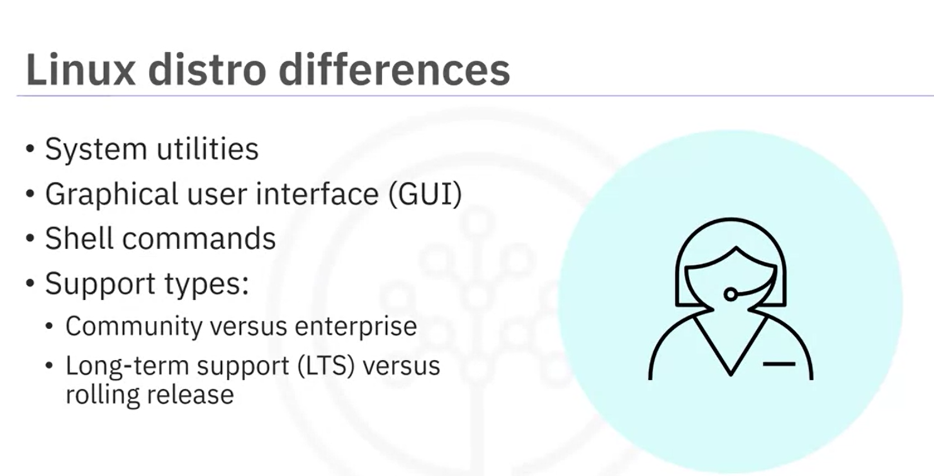

* Different type of Linux distros:

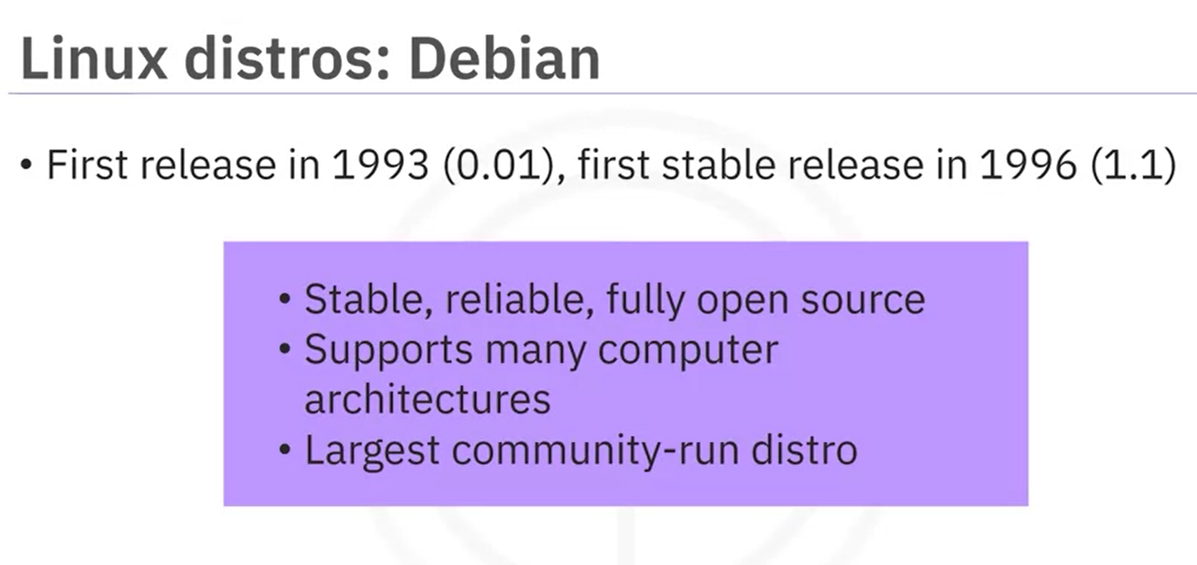

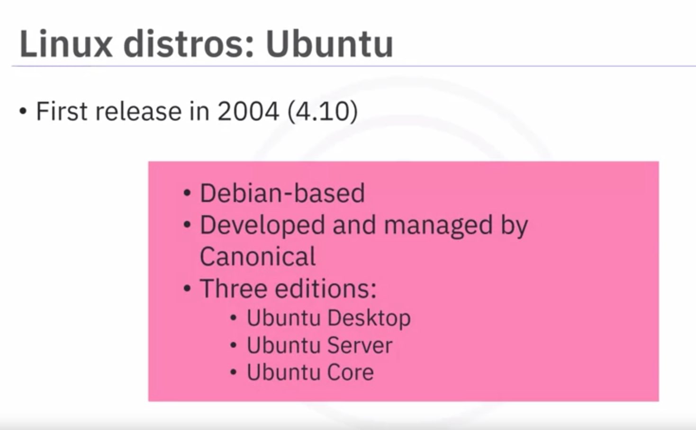

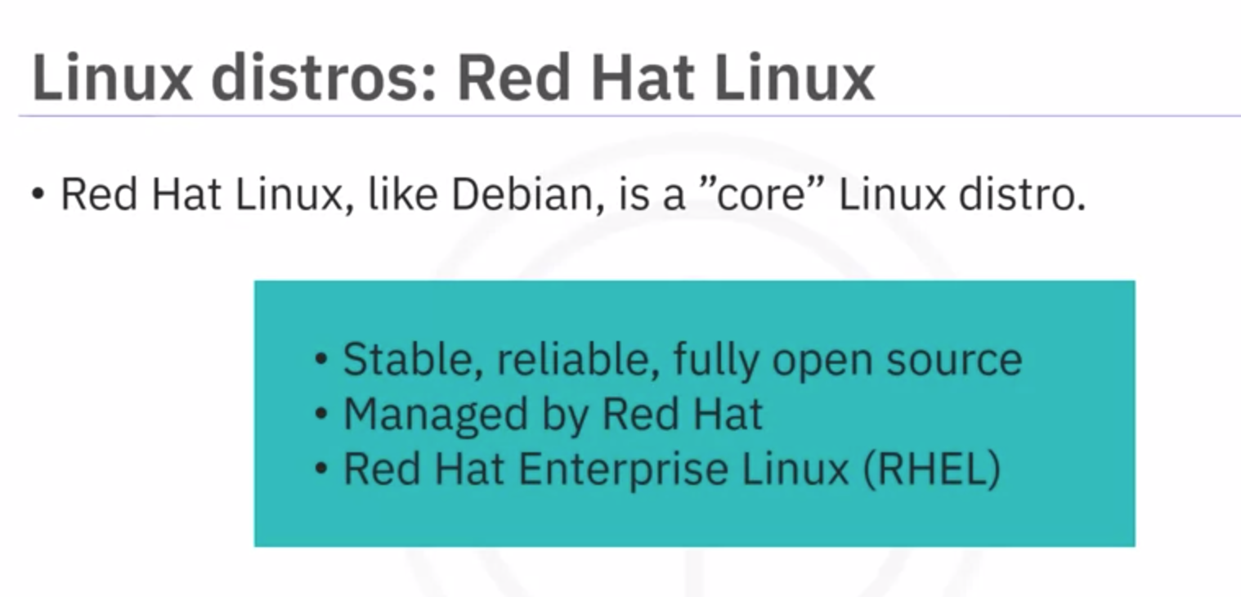

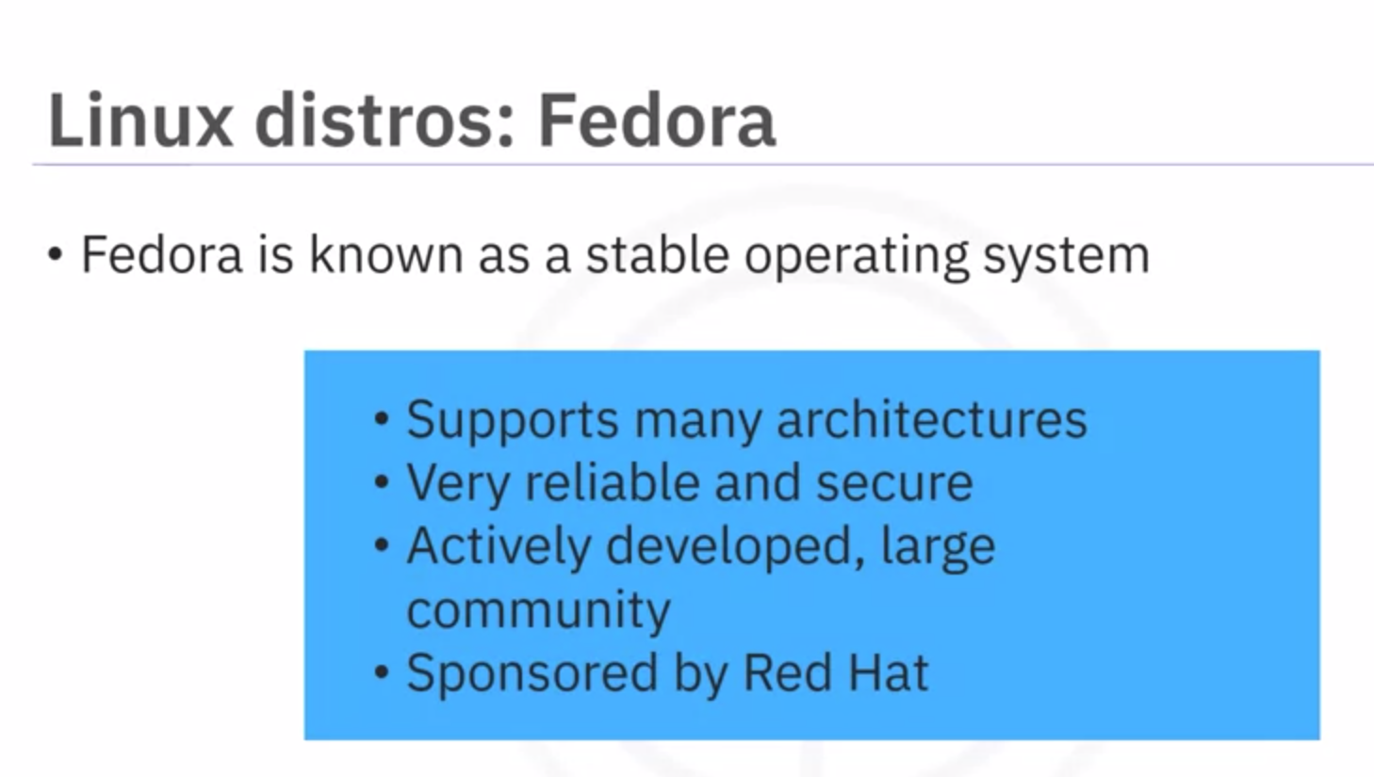

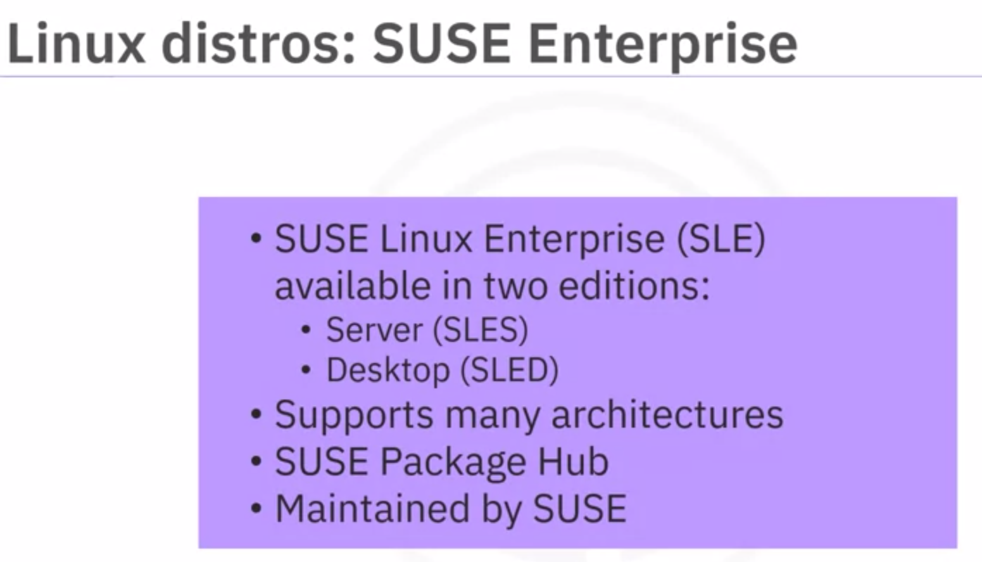



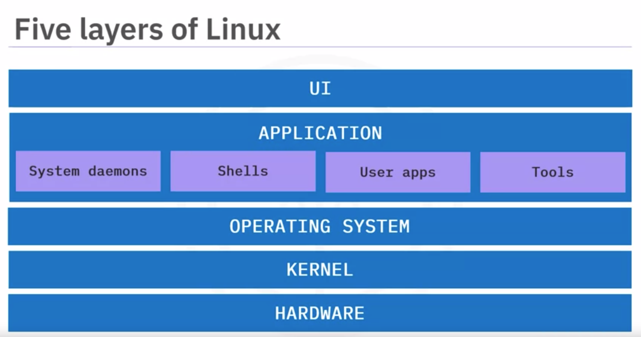



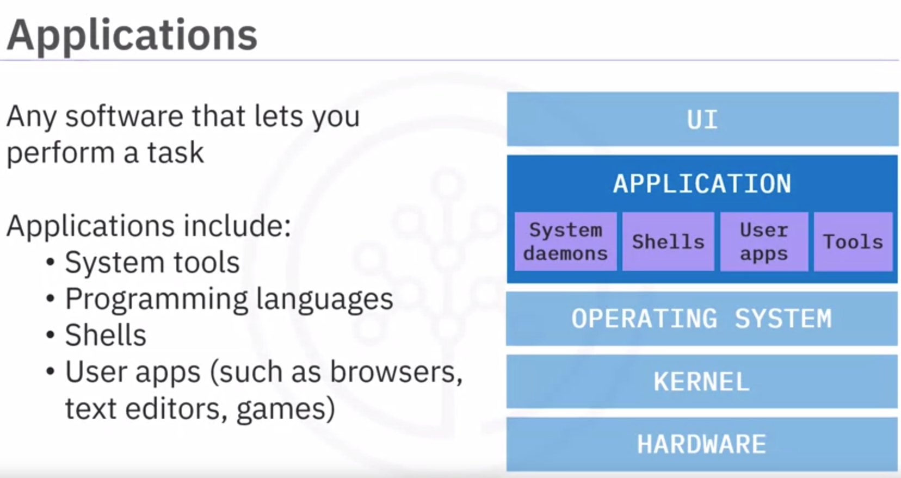

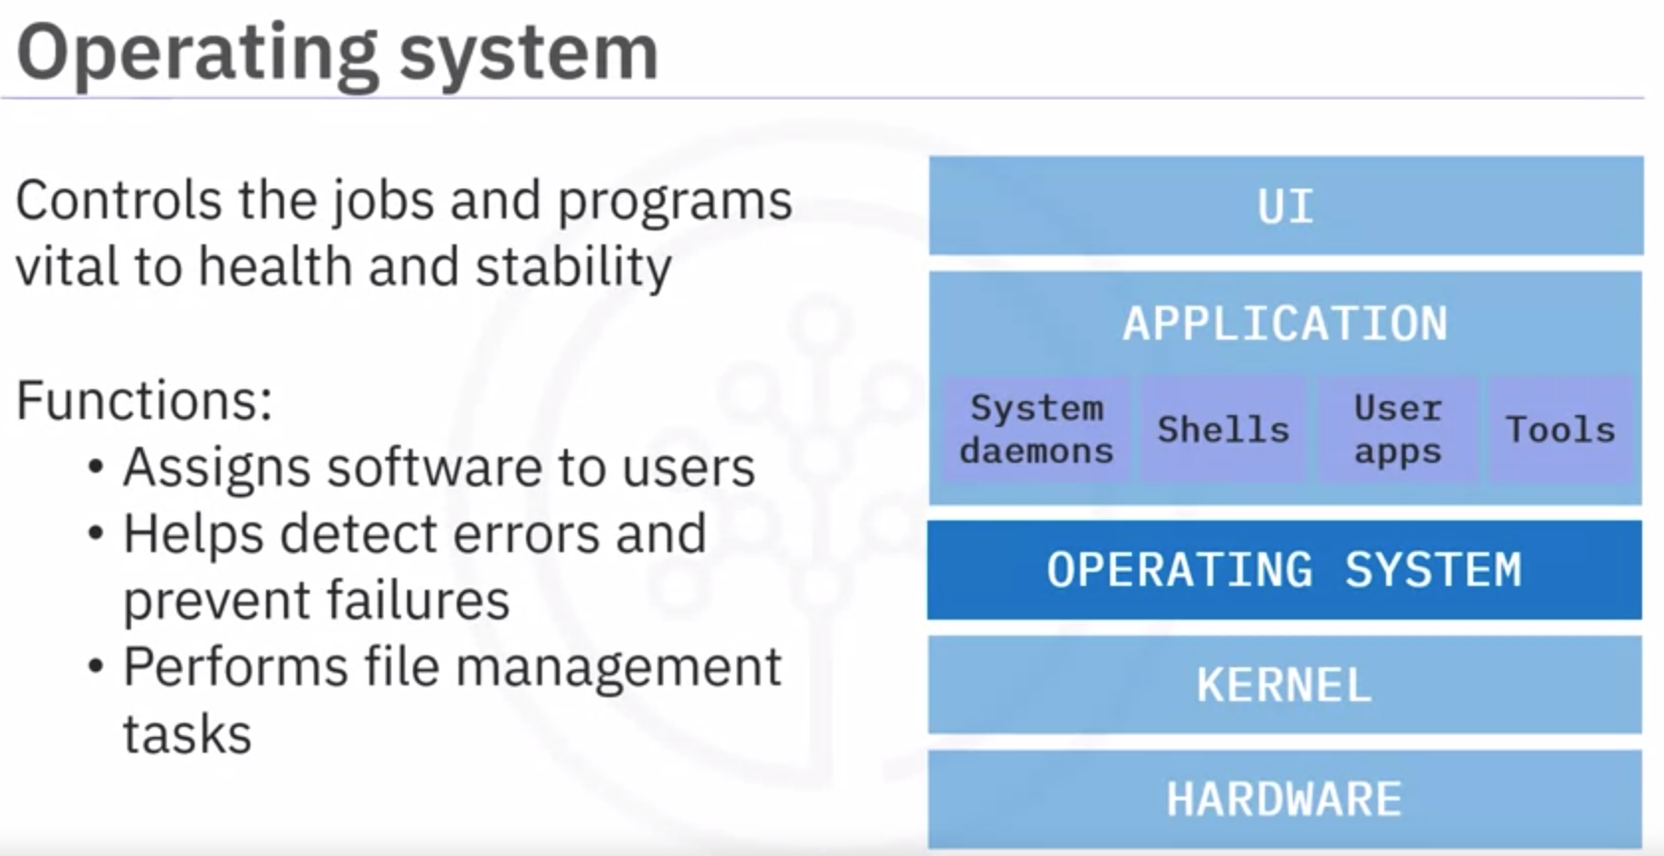

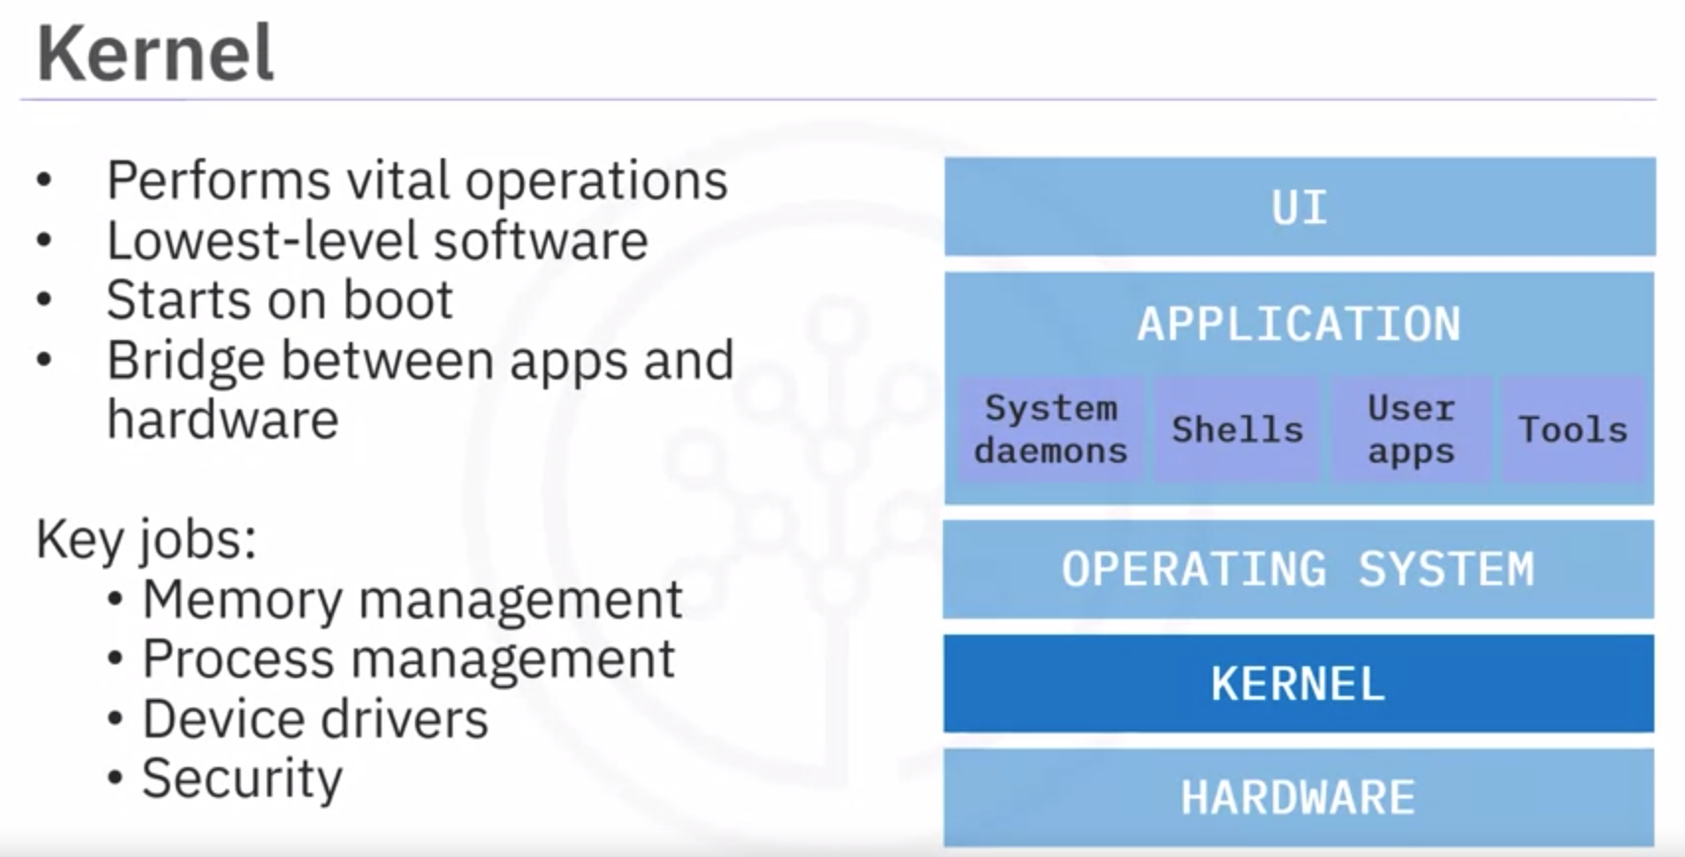

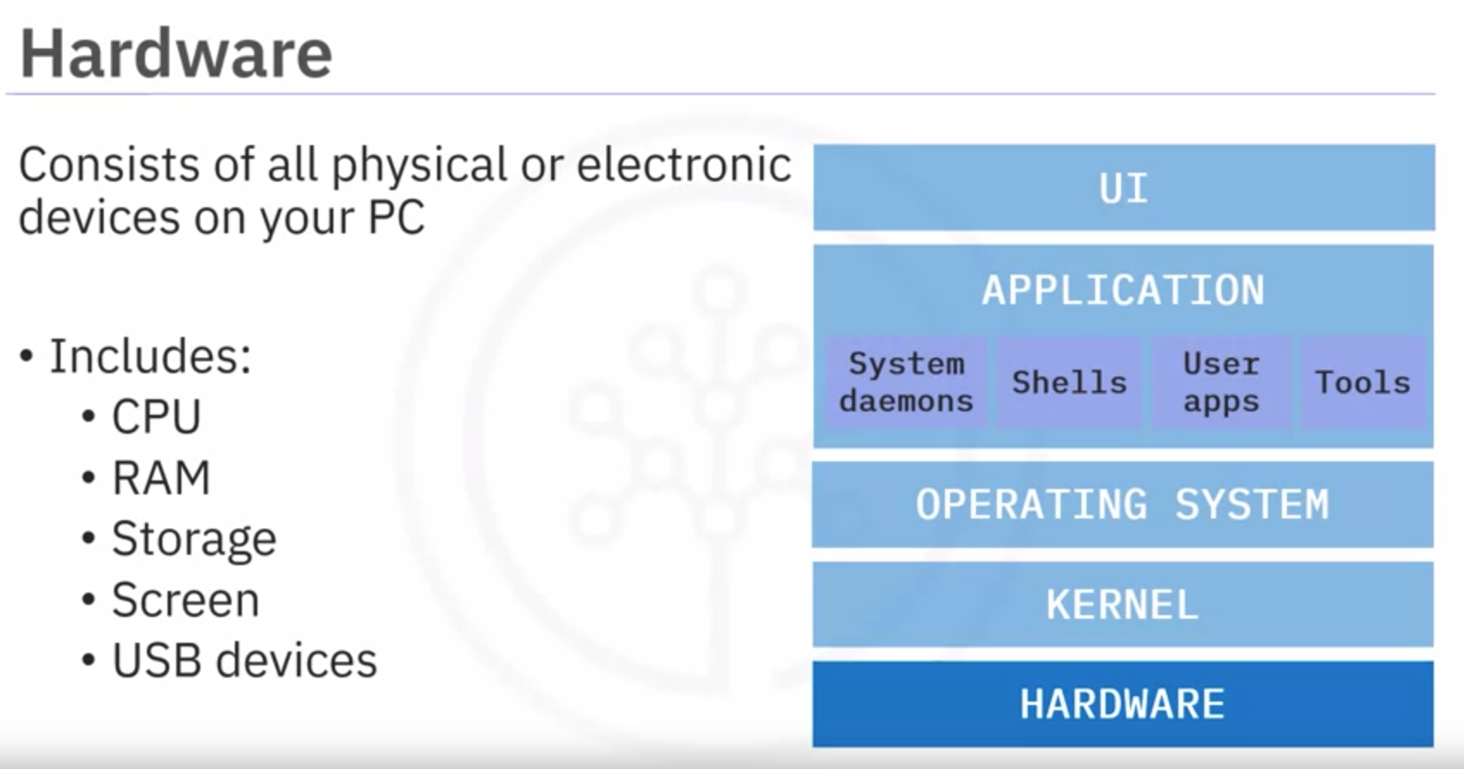

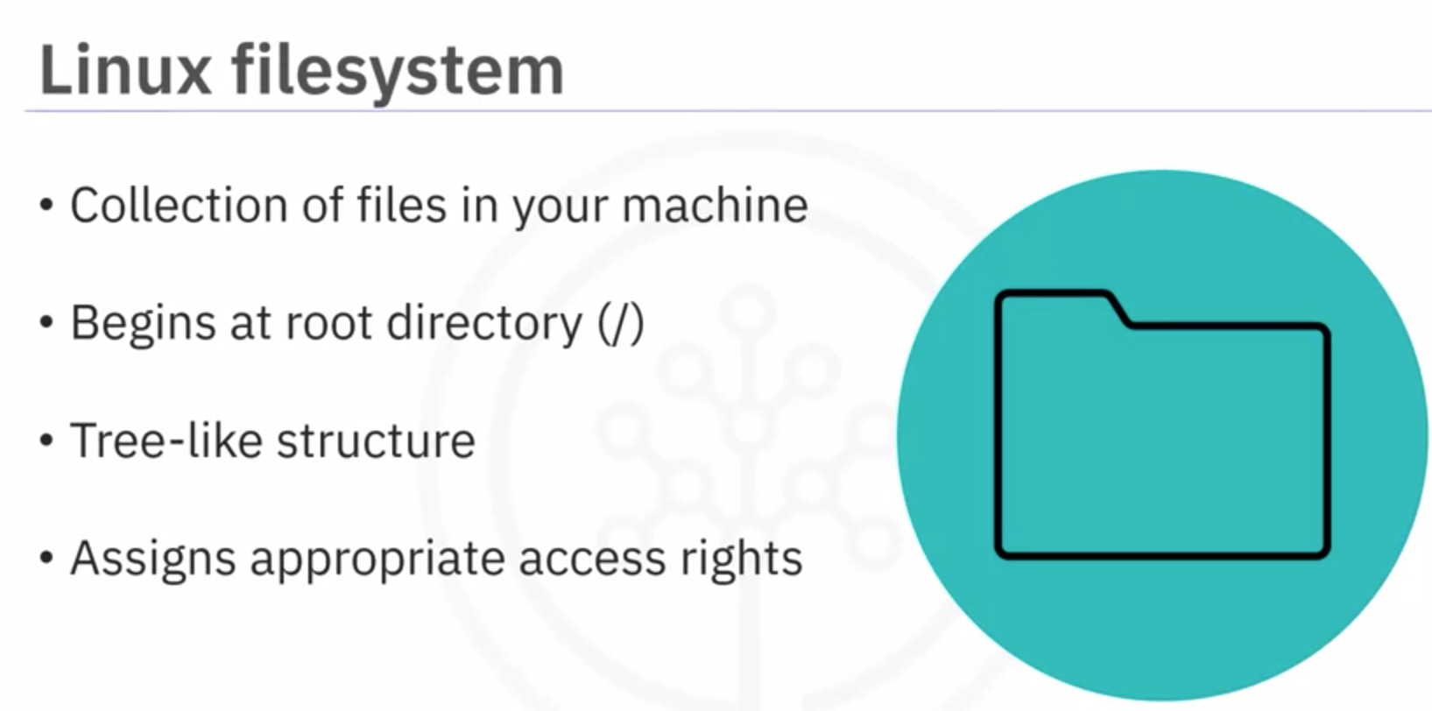

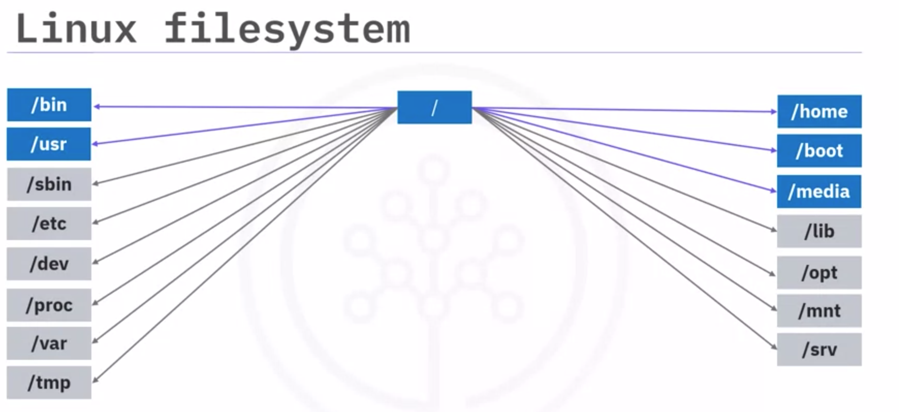One of the key directories is **/bin**, which contains user binary files. Binary files contain the code your machine reads to run programs and execute commands.

It’s called "slash bin" to signify that it exists directly below the root directory.

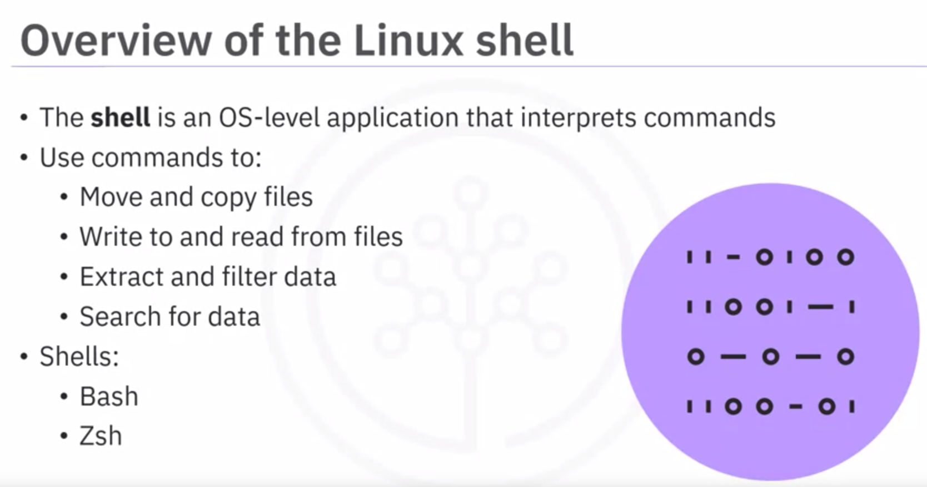

The Linux shell is an OS-level application that interprets commands.

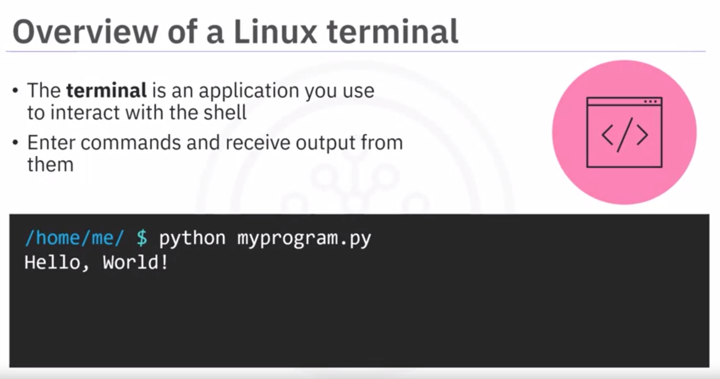

A terminal is an application, or user interface, where you enter the commands, you want to run and receive any output from those commands.

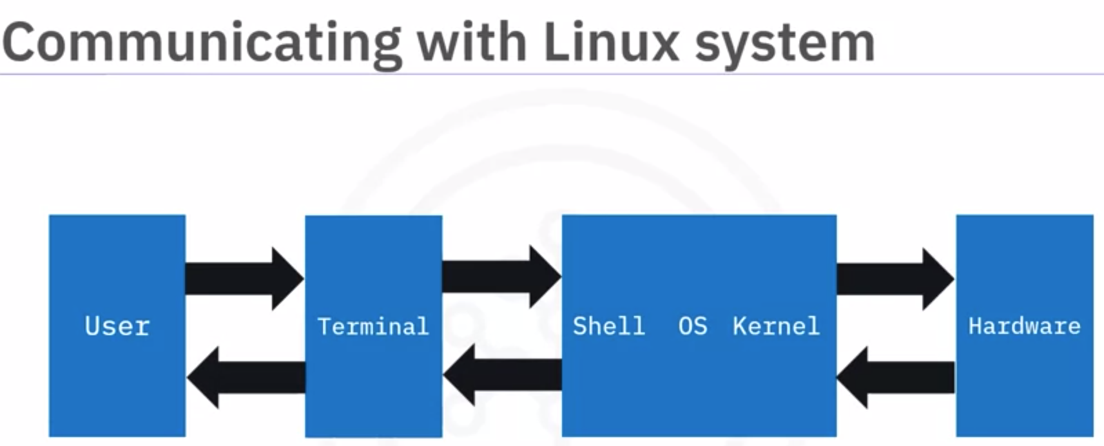

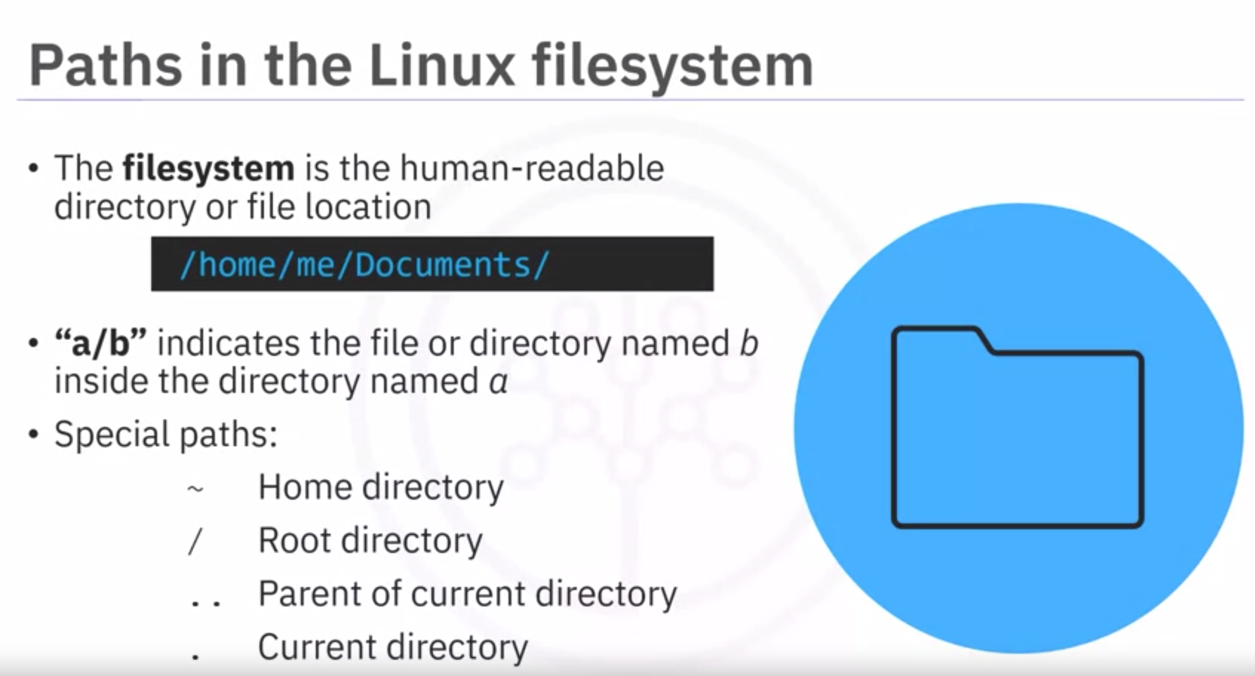







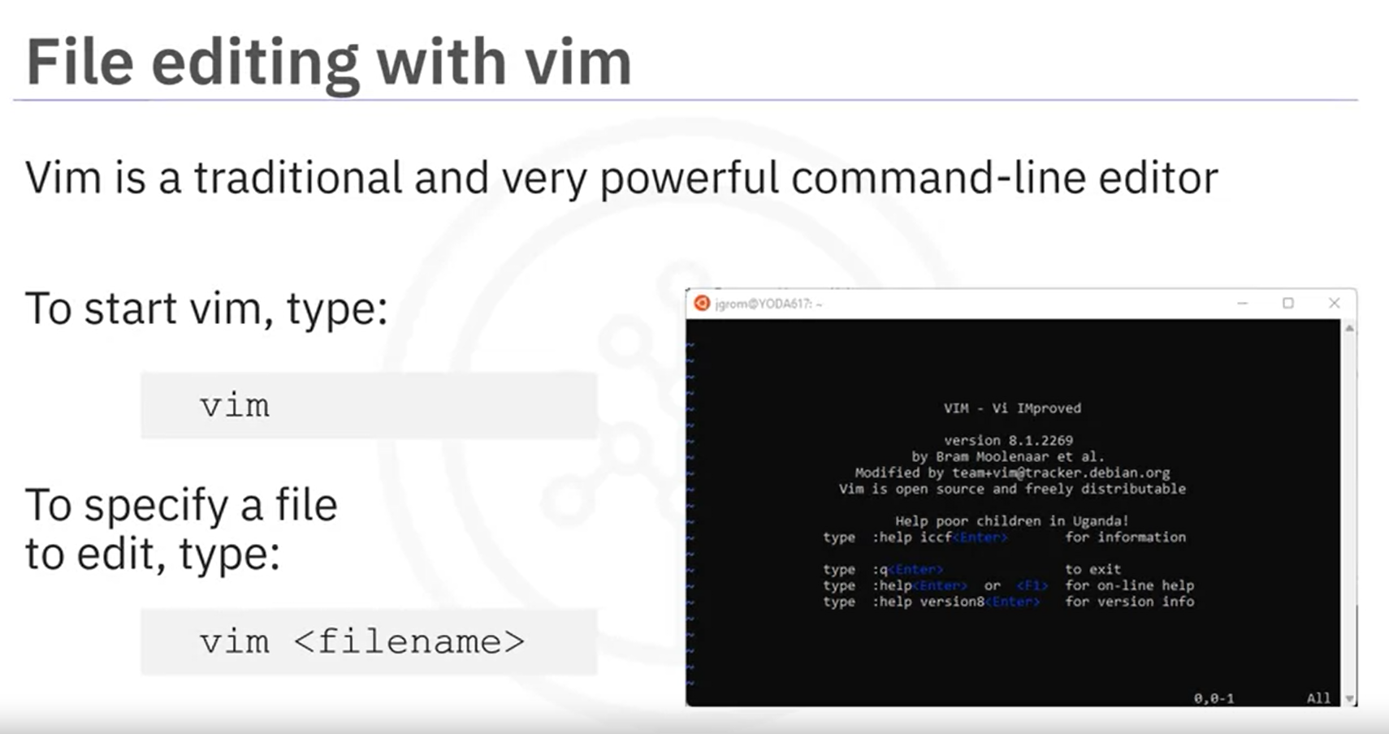

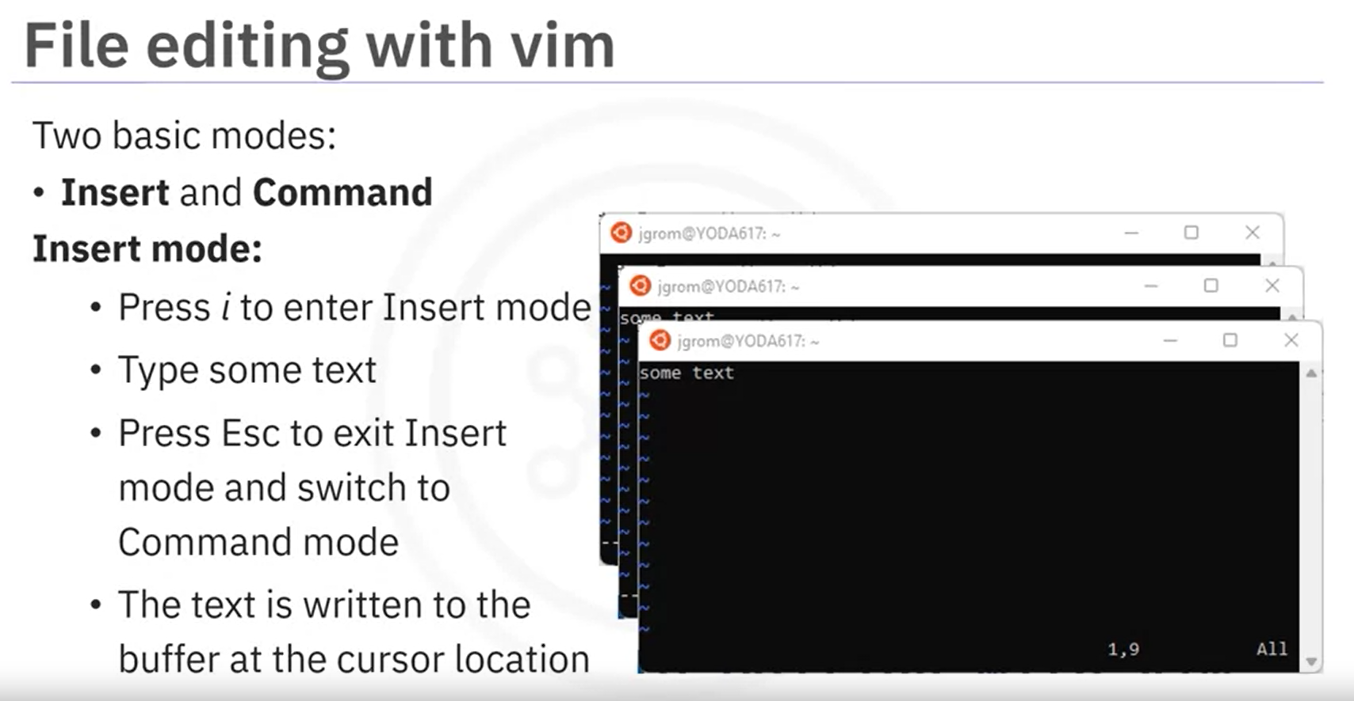

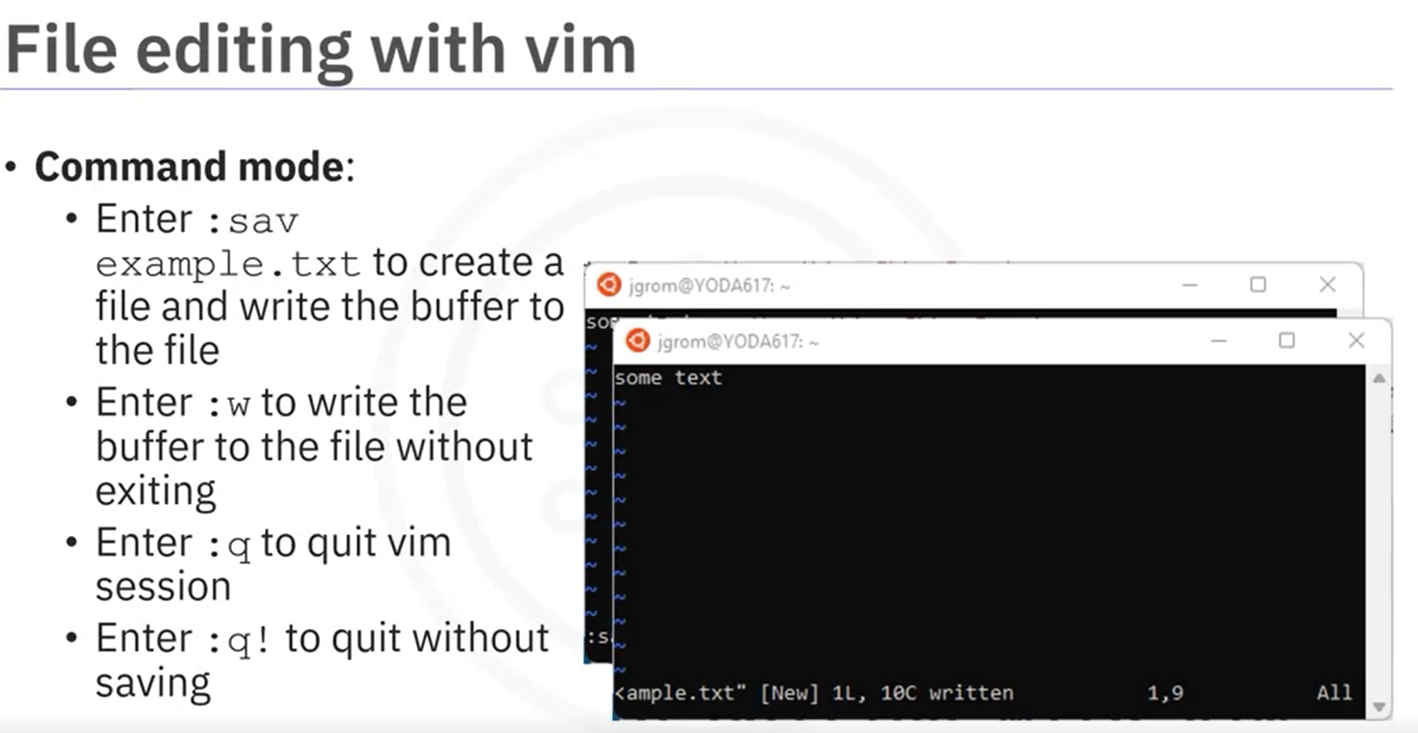

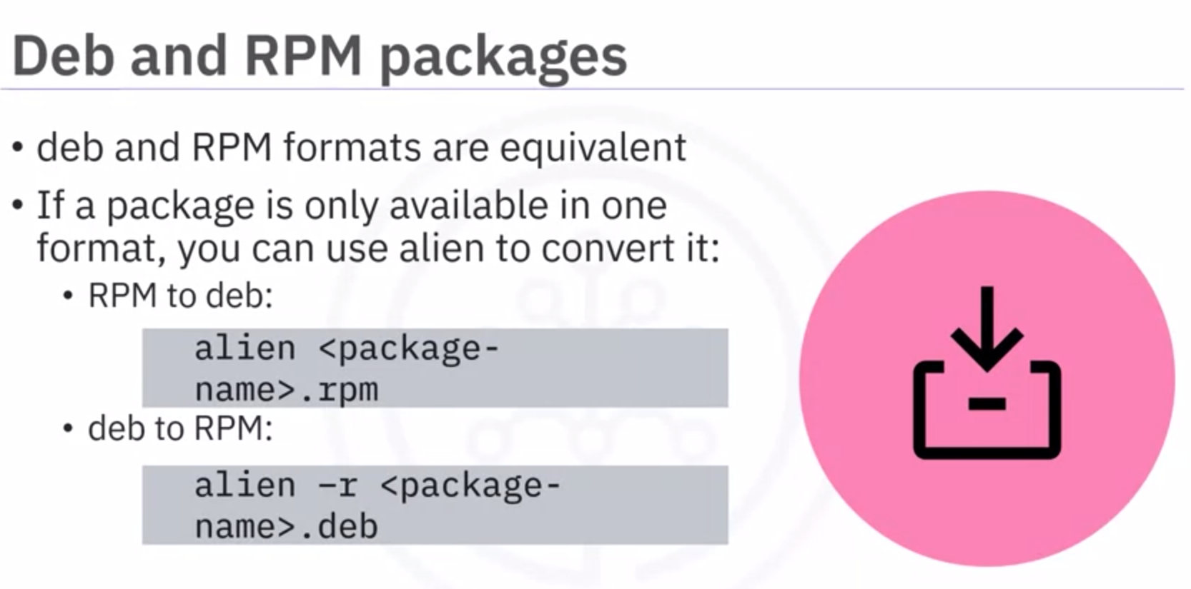

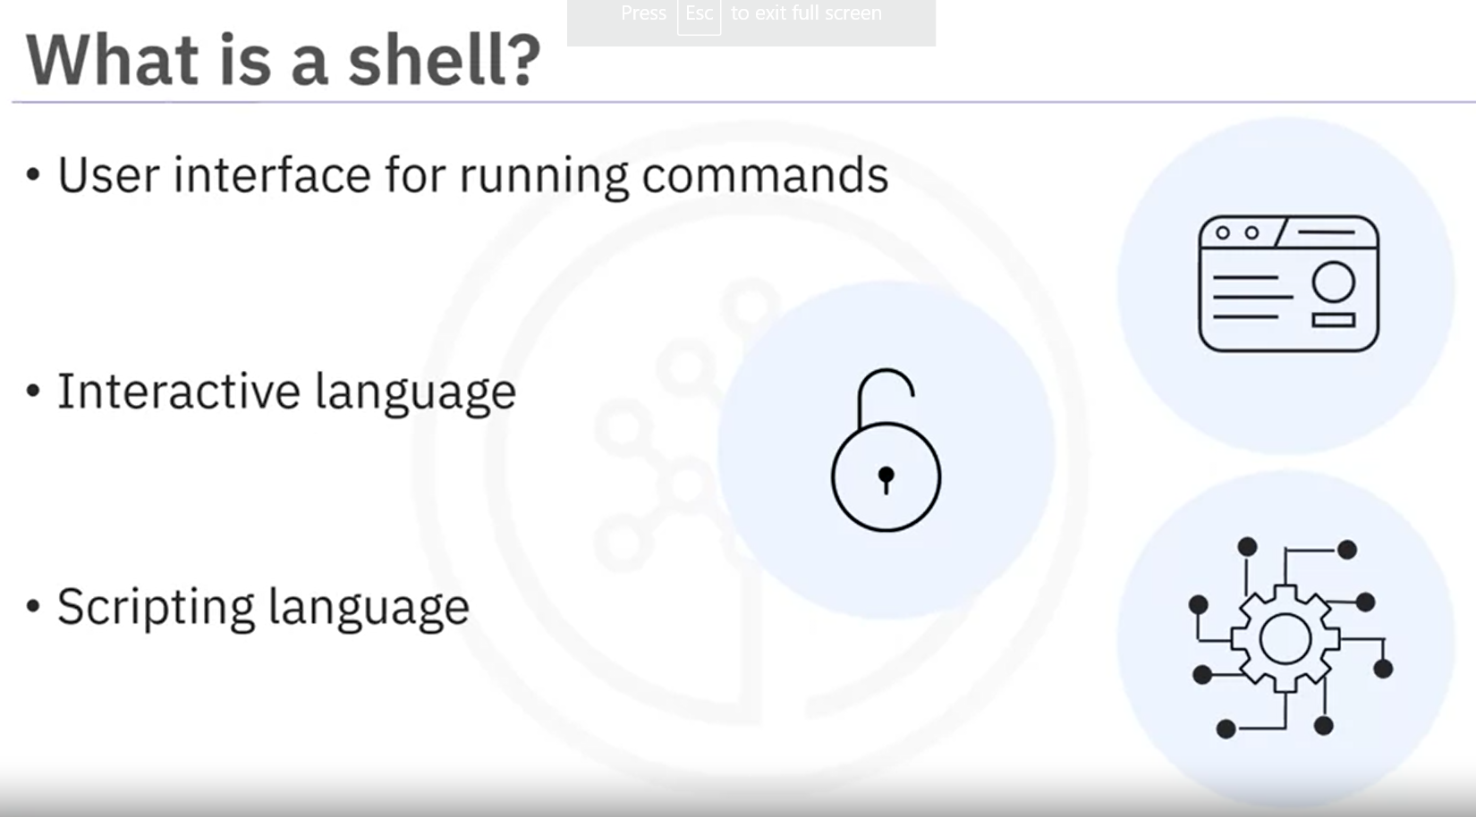

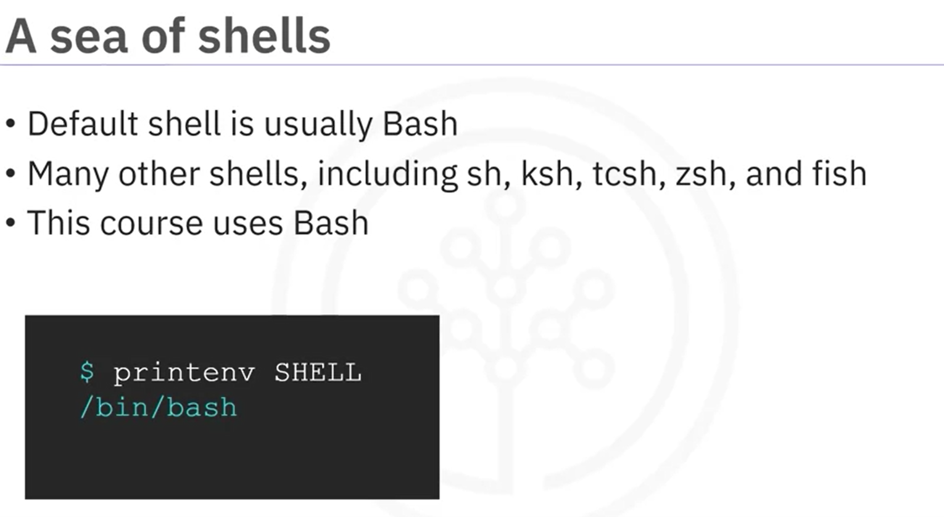

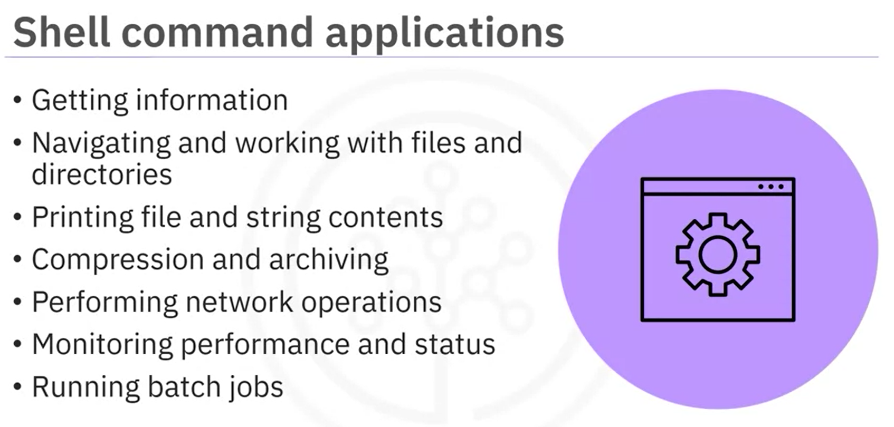

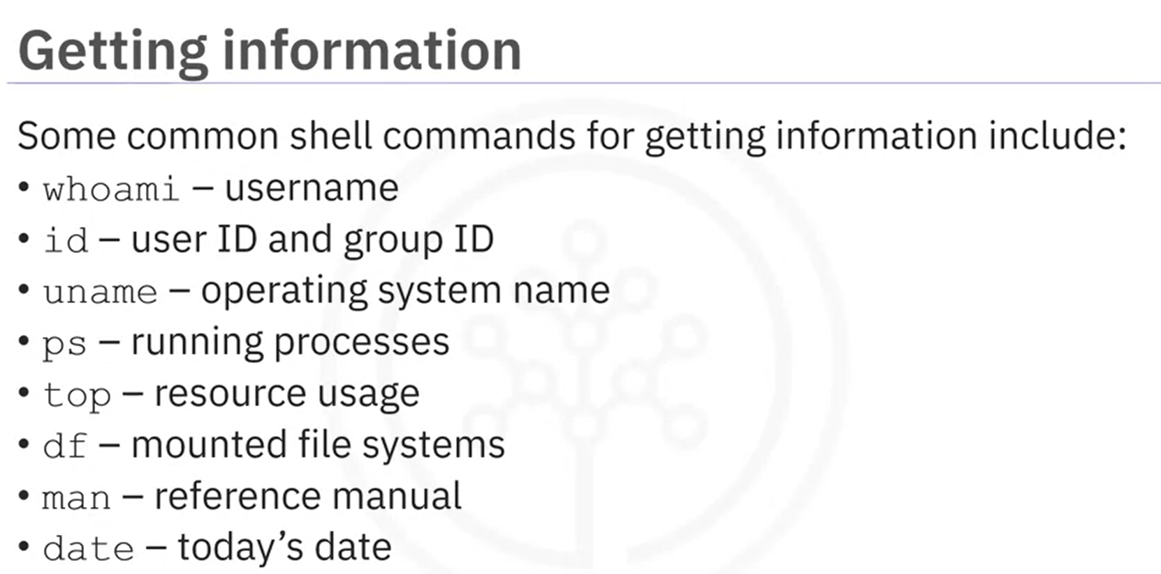

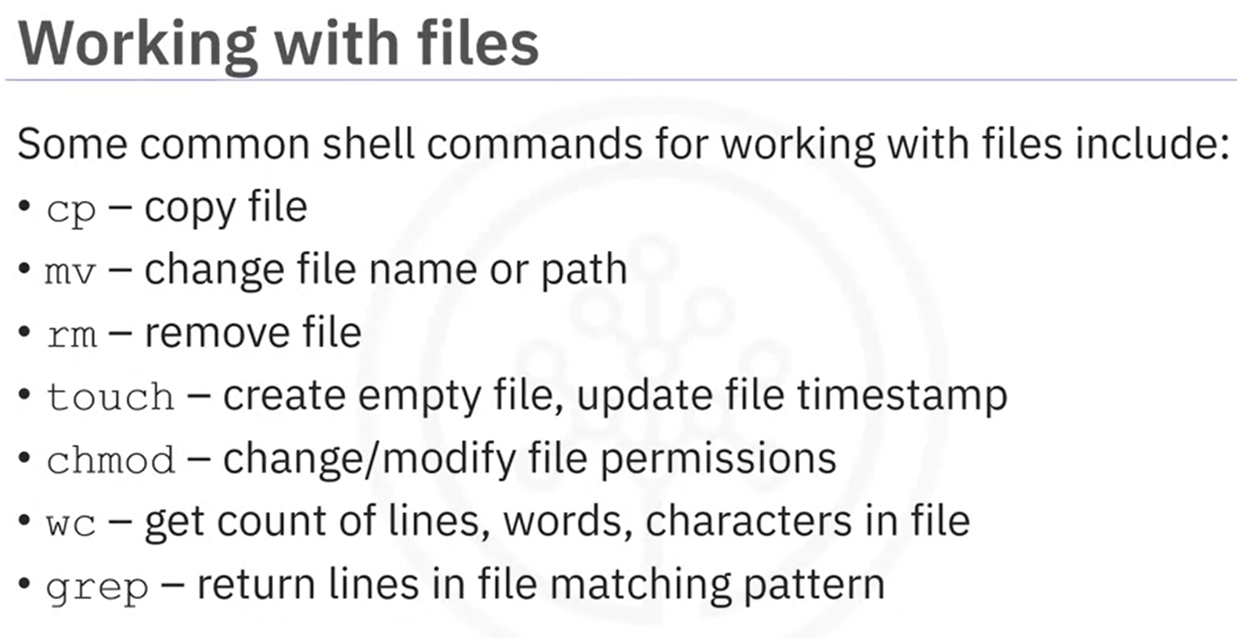

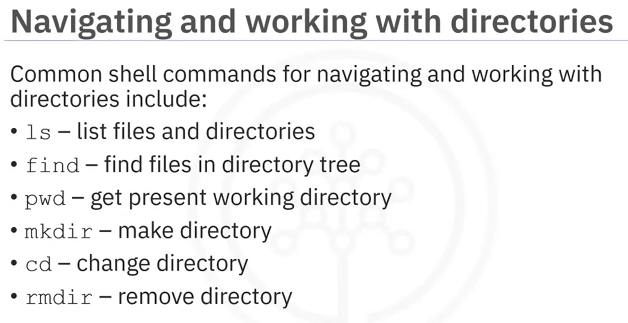

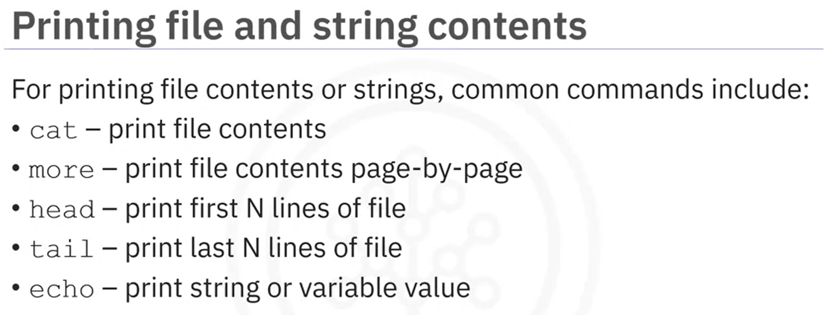

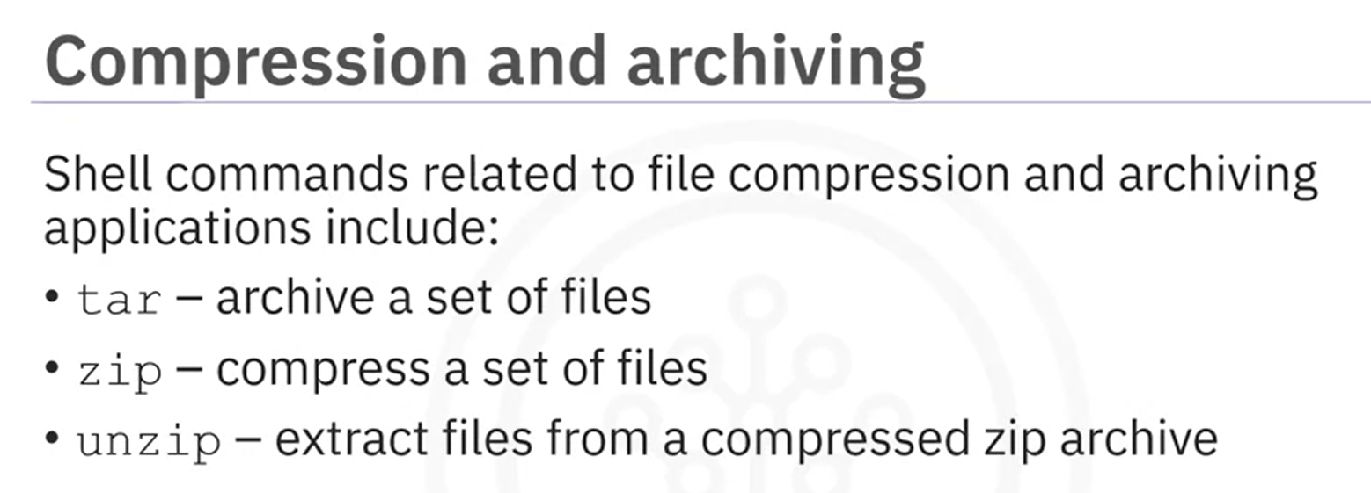

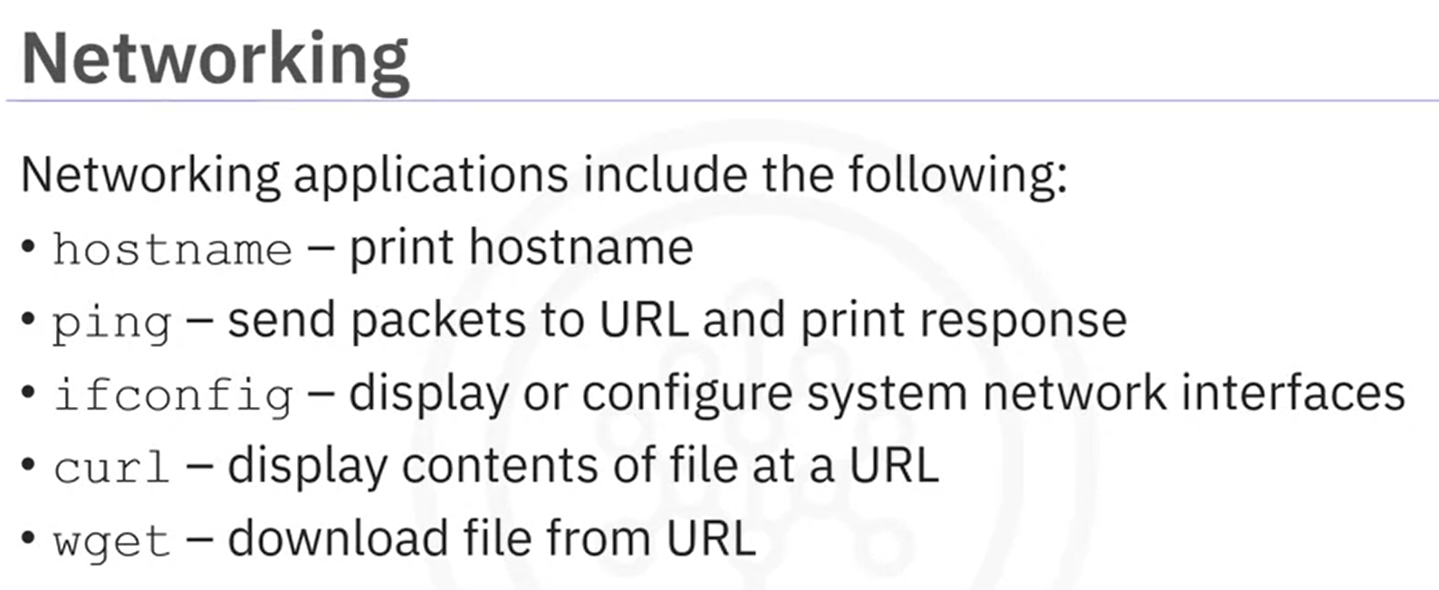

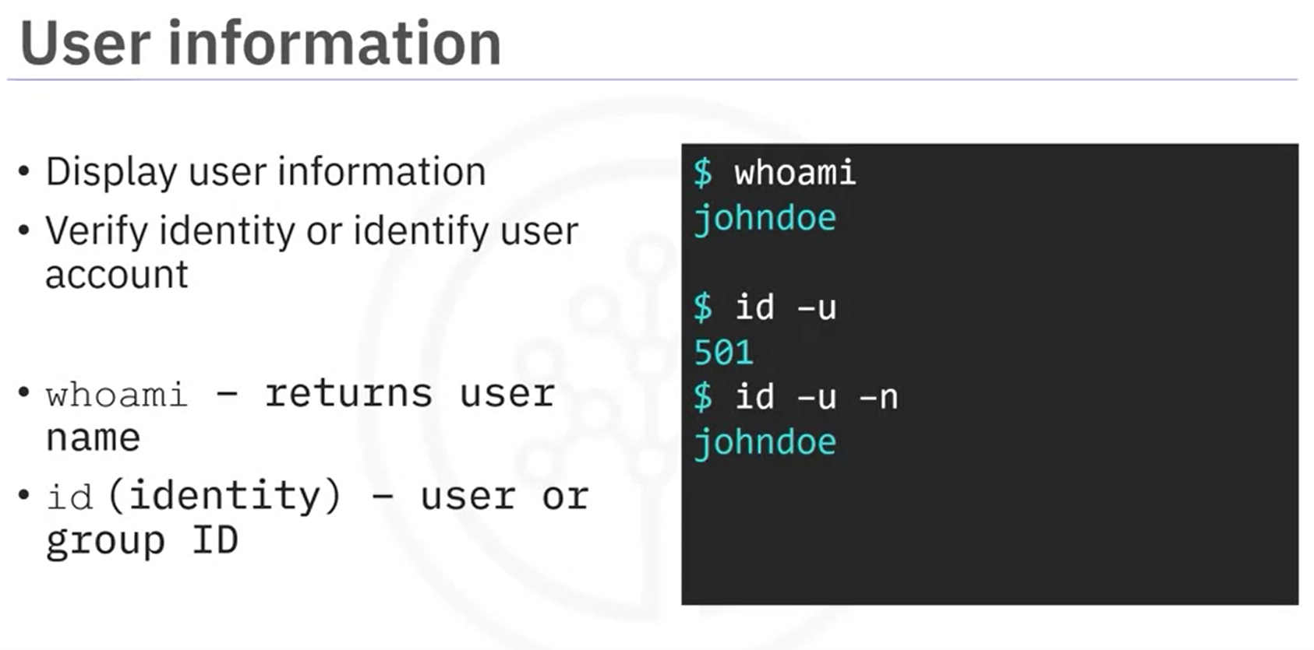

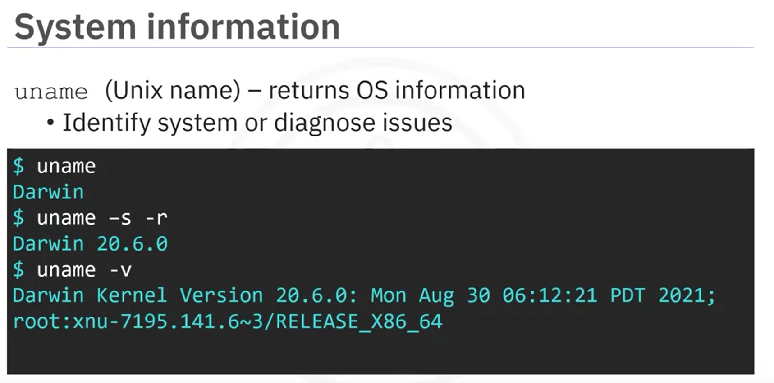

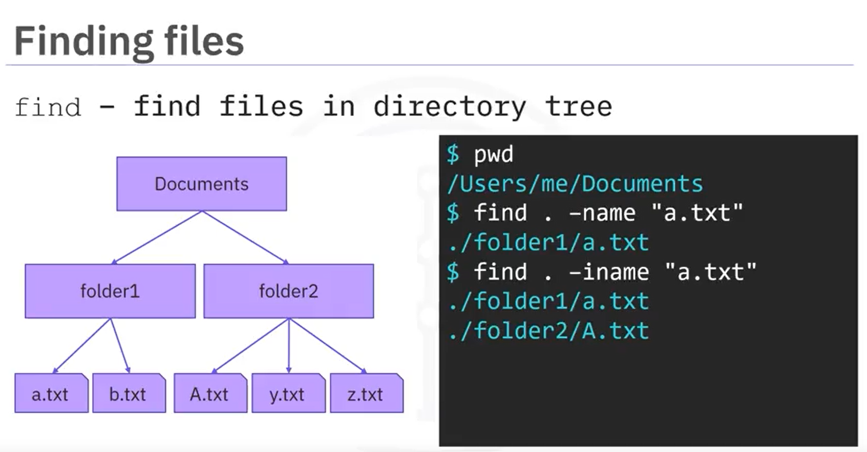

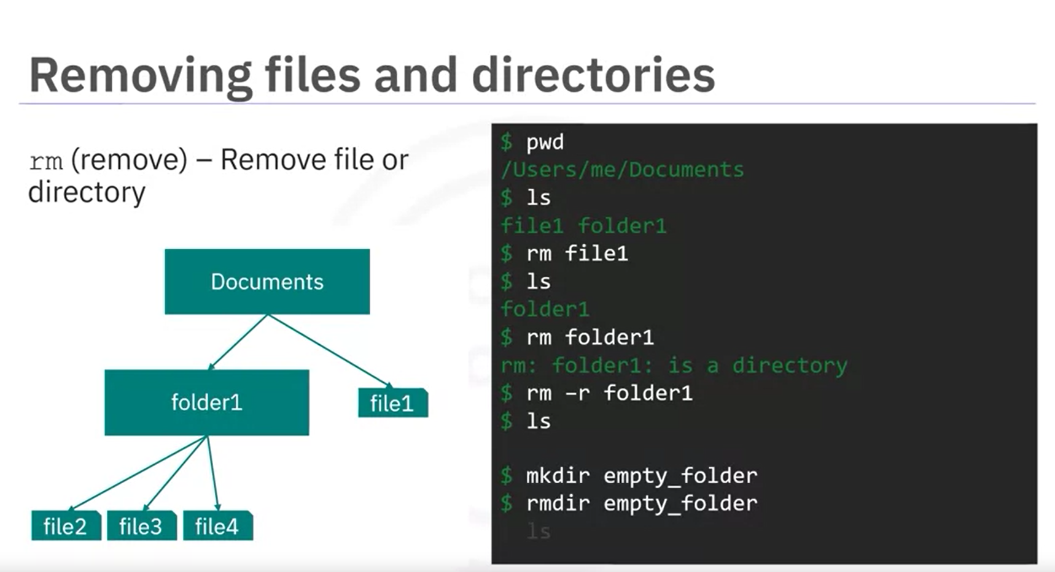

It is recommended not to use rm -rf command on directories as it might delete the files inside a directory, so use rmdir command instead to delete an empty folder.

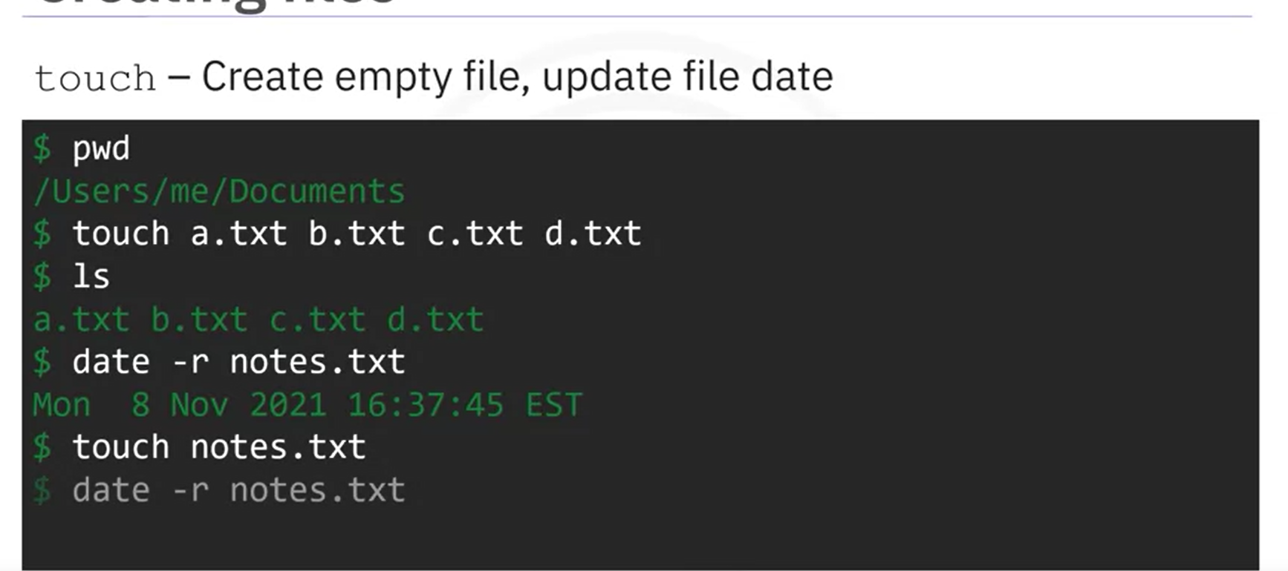

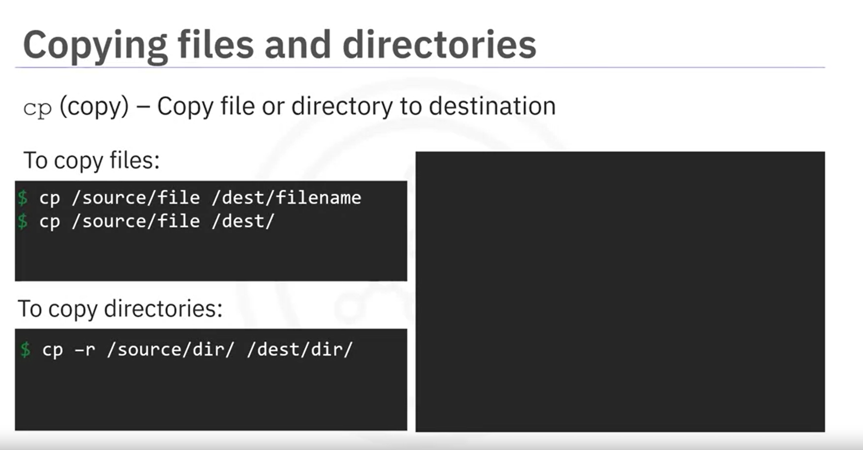

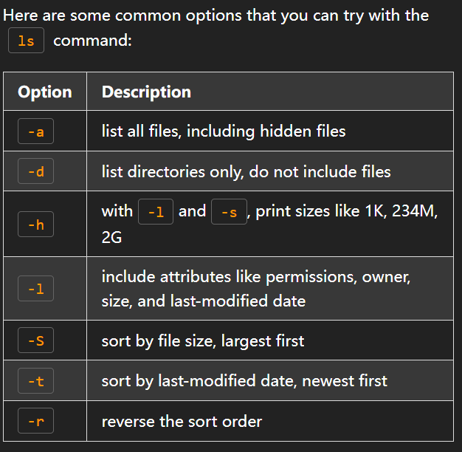

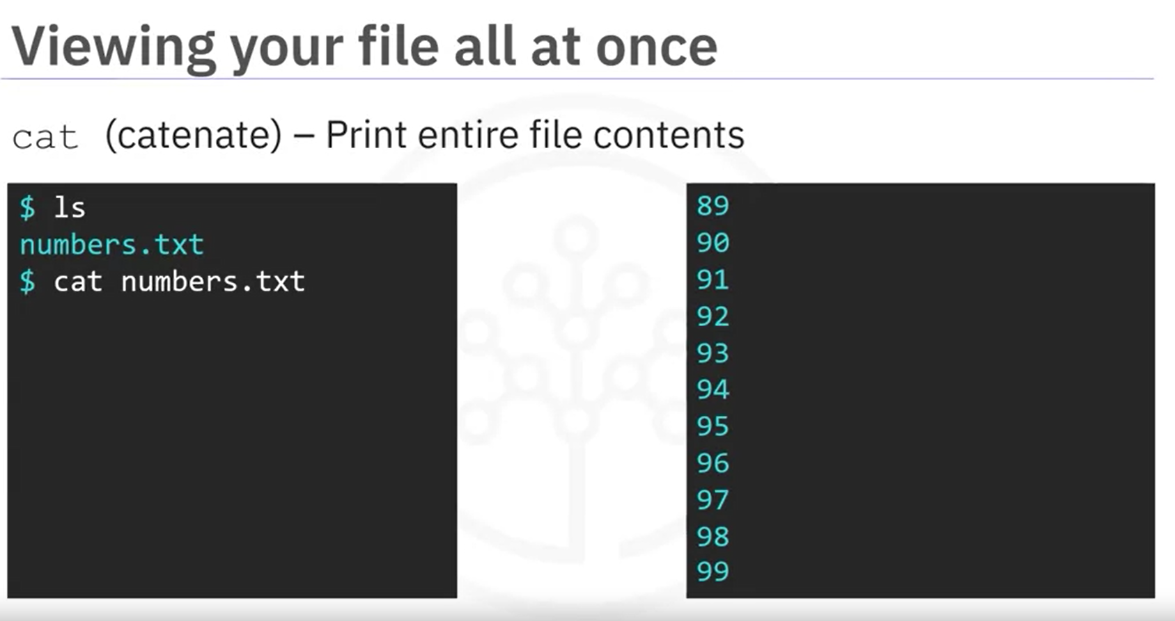

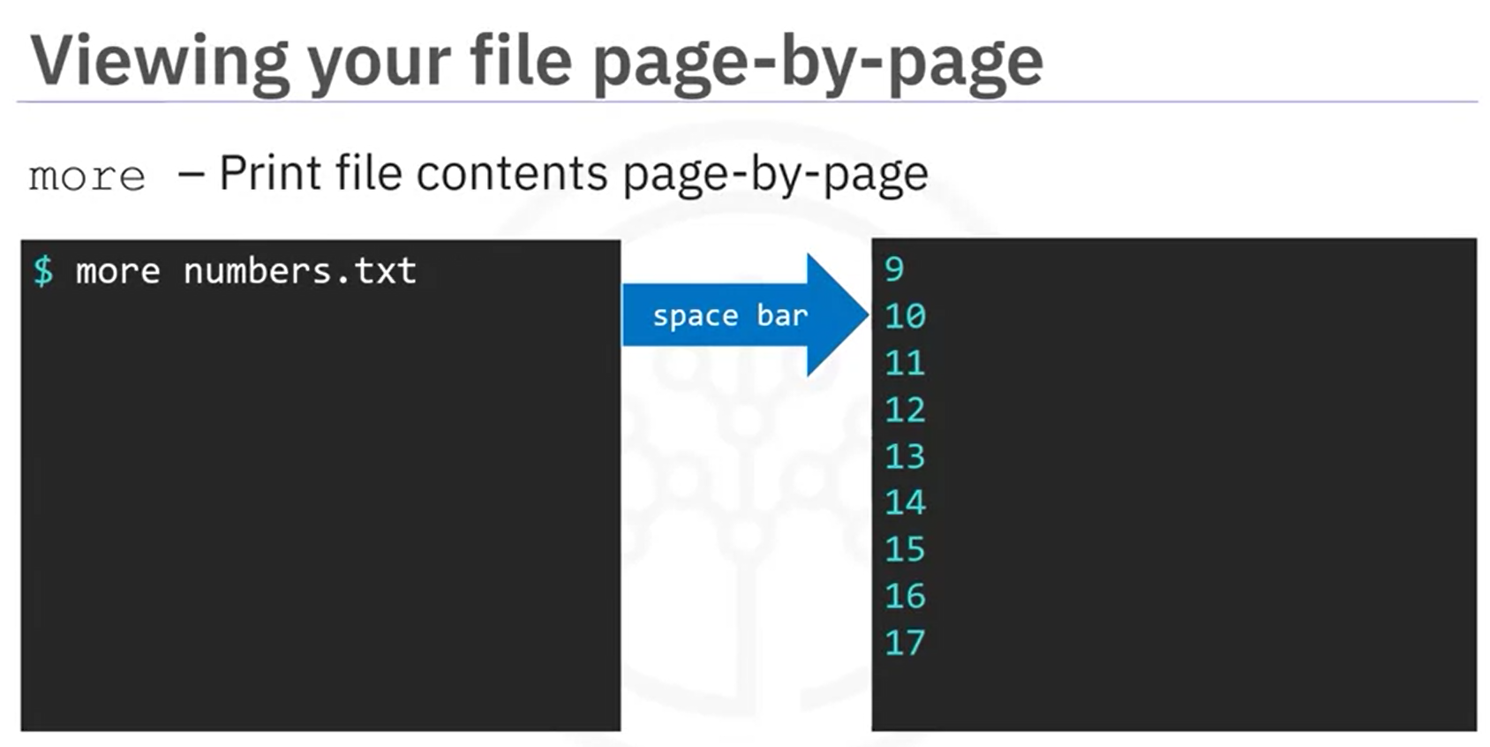

You can also use *less* to vie the contents. Using *less*, you can move up & down the contents using up & down arrow or Pg up & Pg down. You can also use space to jump to next frame or enter to next line. Press q to exit.

Using *more*, you can only go down. You can use space to jump to next frame or enter to next line. *more* will automatically quit at the end of the line. Or press q to exit.

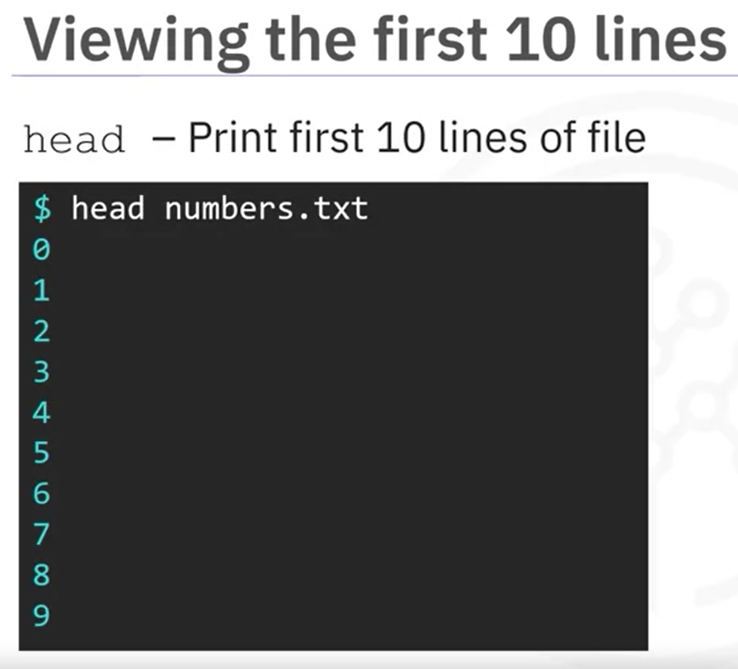 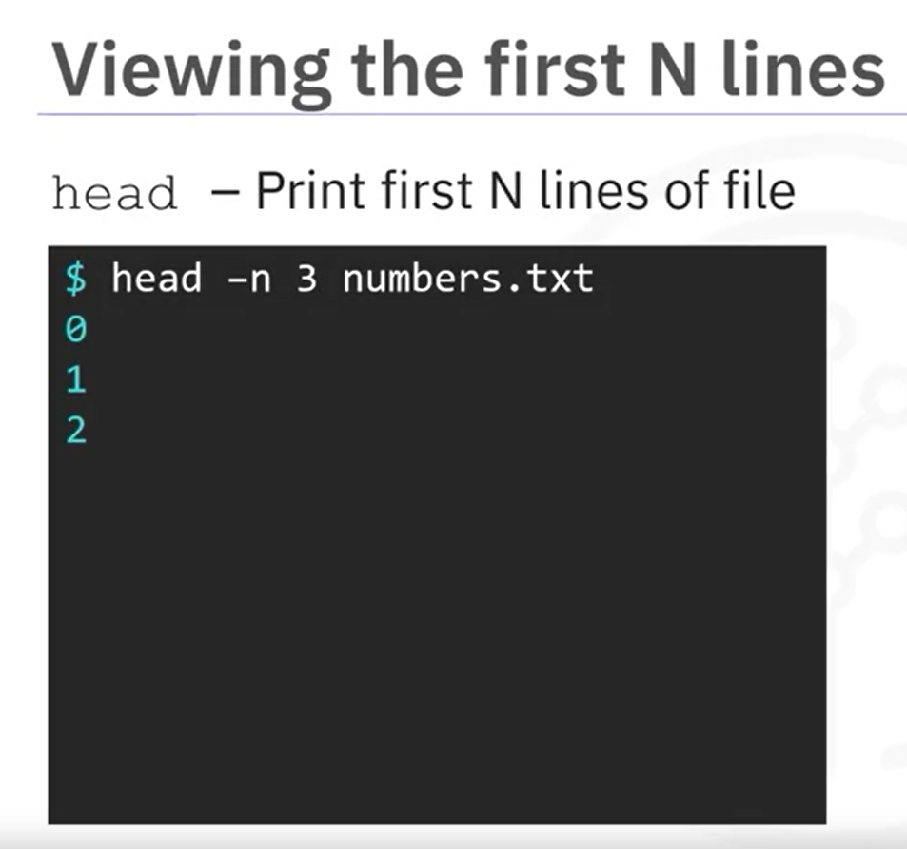

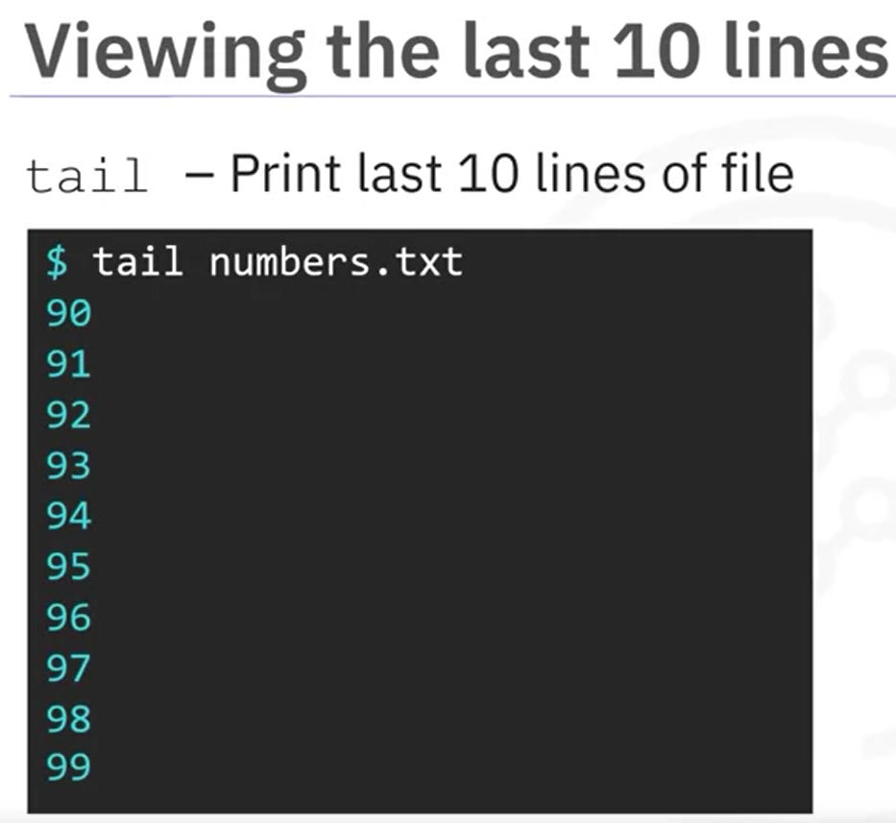 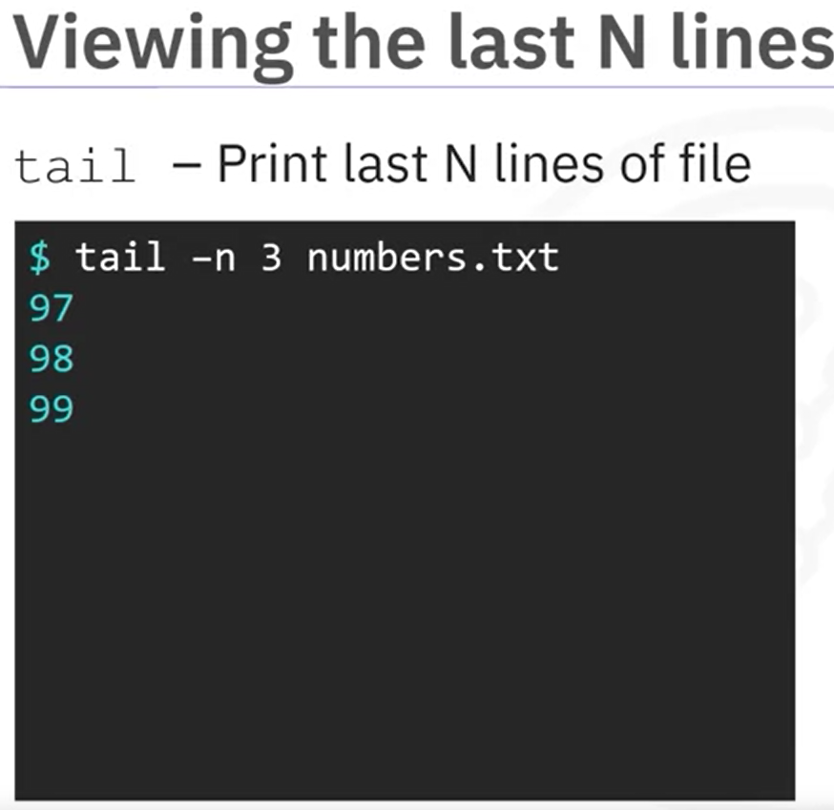

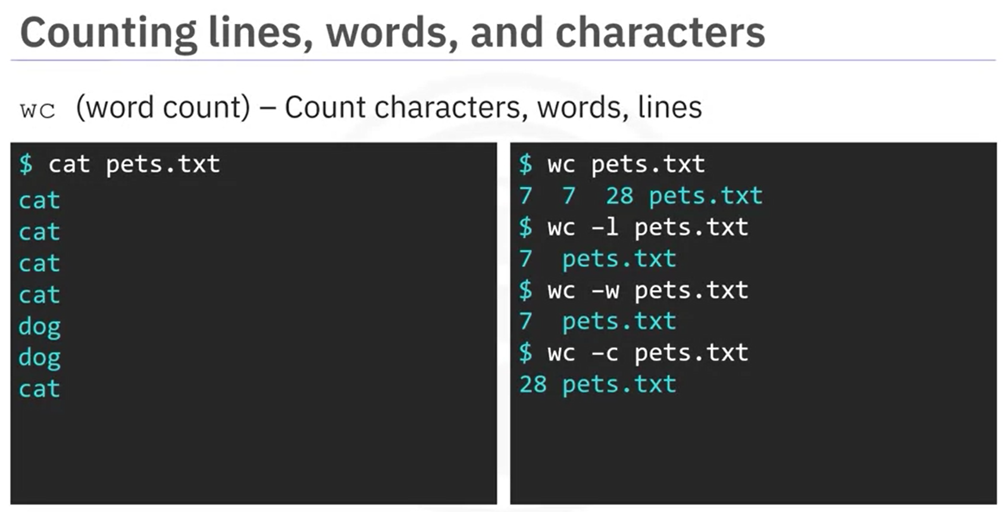

*wc* gives result in format <lines words characters file_name>

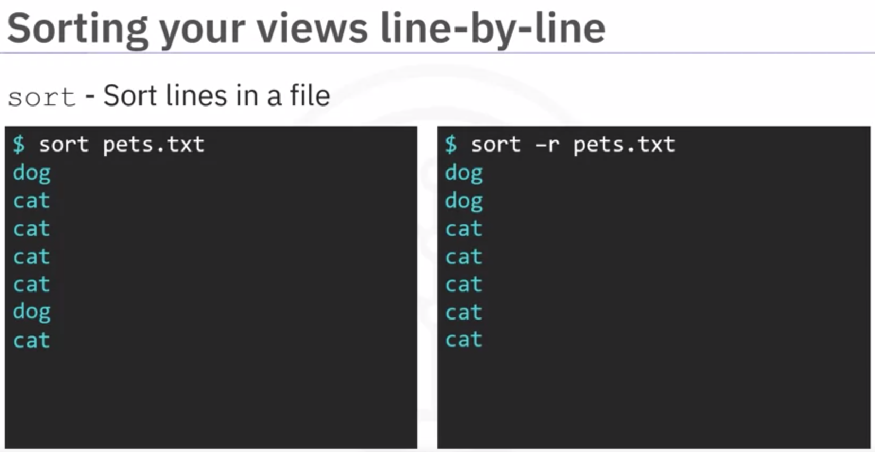

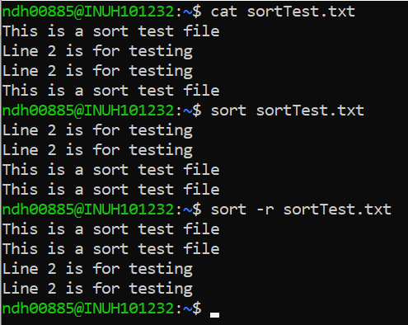

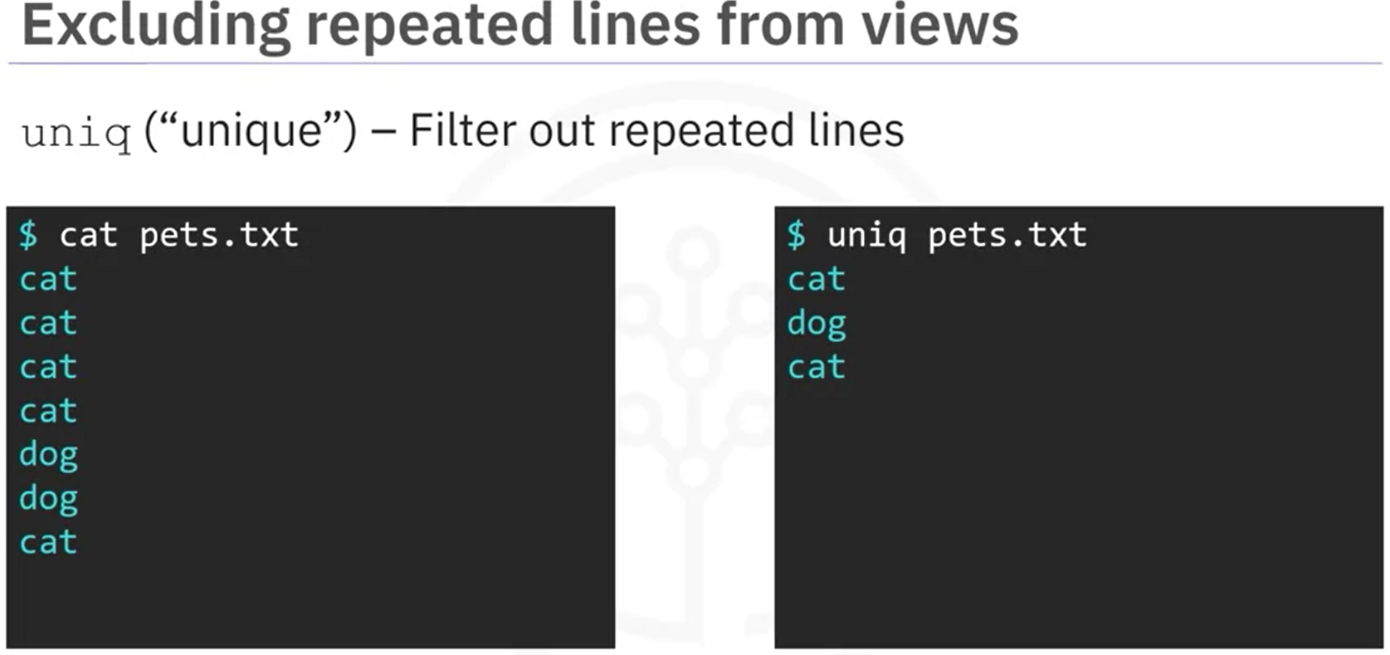

*uniq* command removes duplicate lines only if they are conscutive

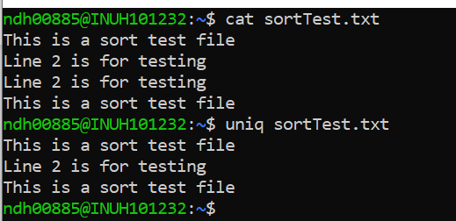

**Grep**

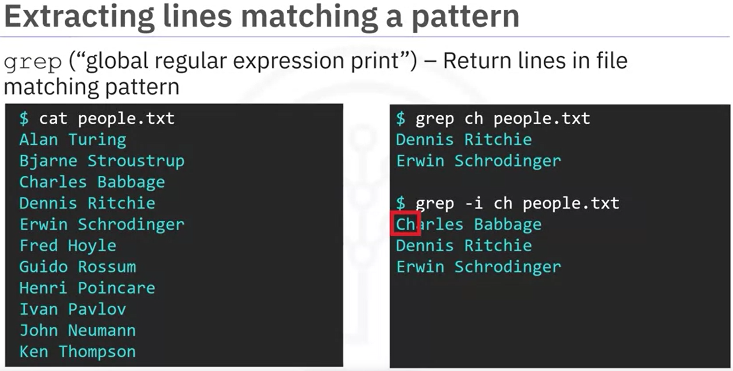

grep -oE "\"price\"\s*:\s*[0-9]*?\.[0-9]*"

Let's break down the details of this statement:

* -o tells grep to *only* return the matching portion
* -E tells grep to be able to use extended regex symbols such as ?
* \"price\" matches the string "price"
* \s* matches any number (including 0) of whitespace (\s) characters
* : matches :
* [0-9]* matches any number of digits (from 0 to 9)
* ?\. optionally matches a .

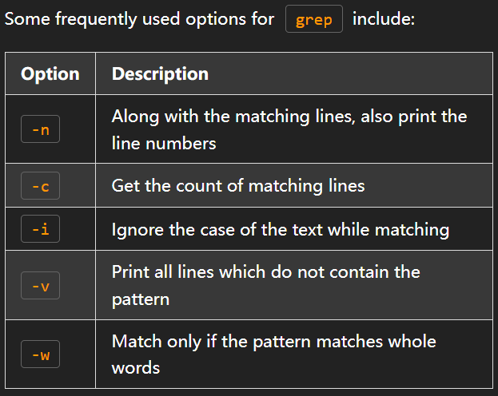

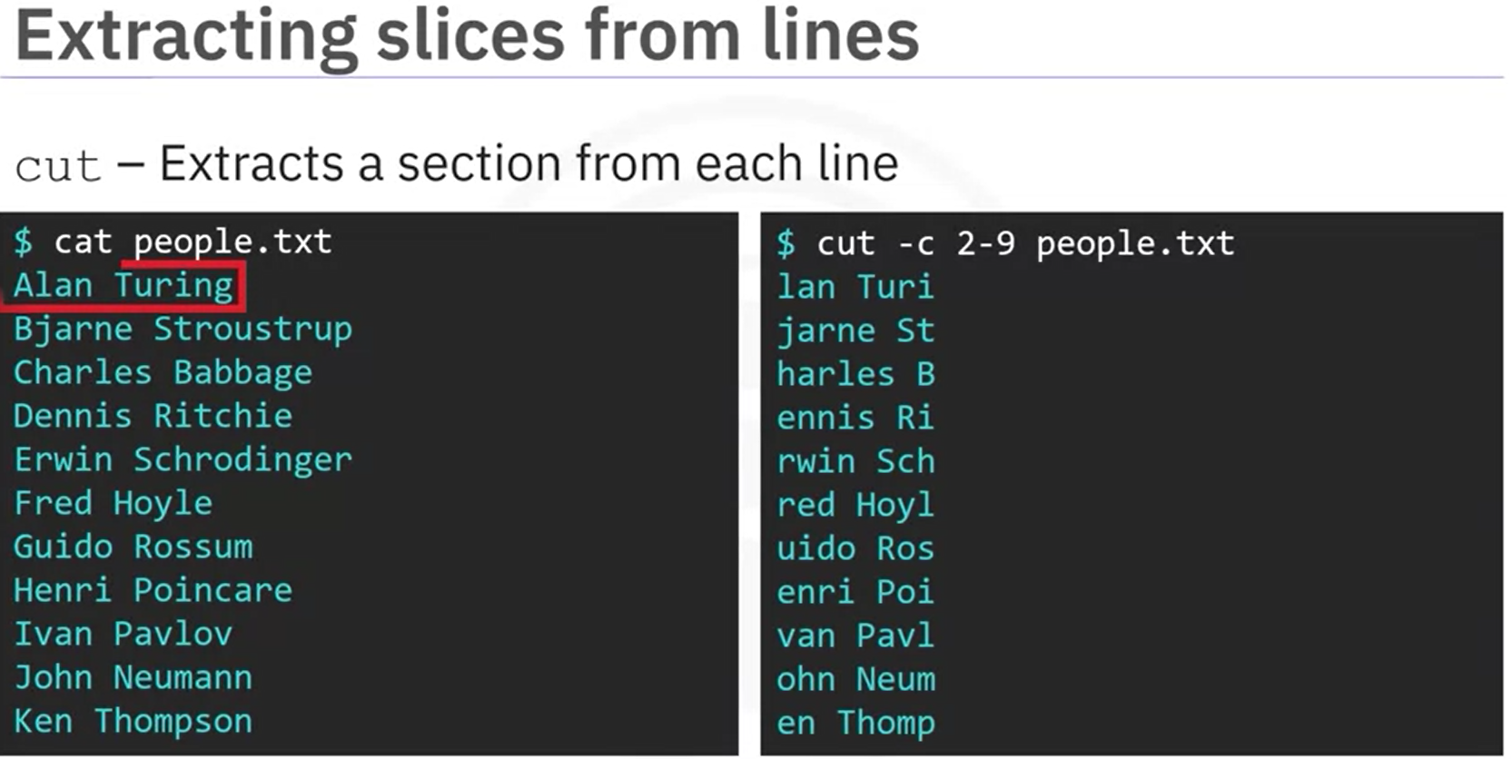

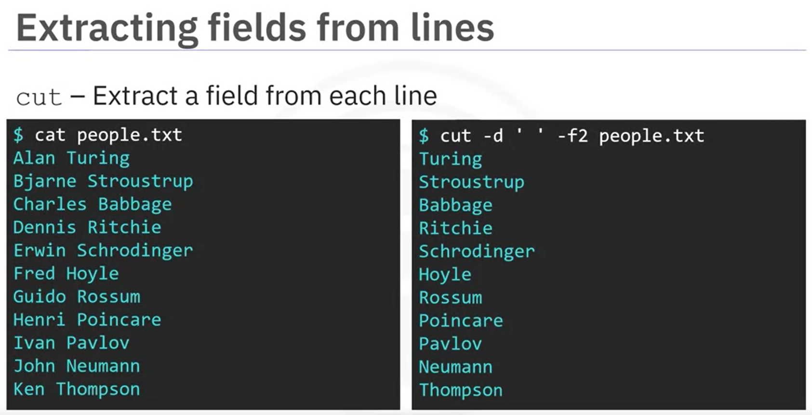

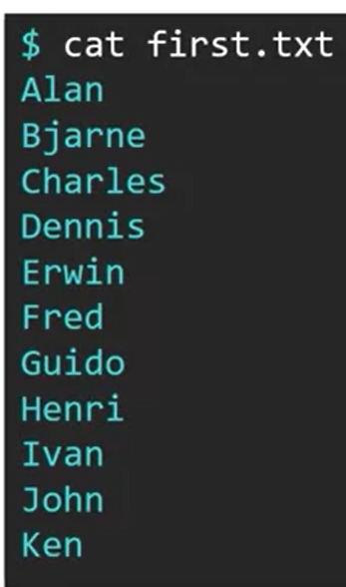 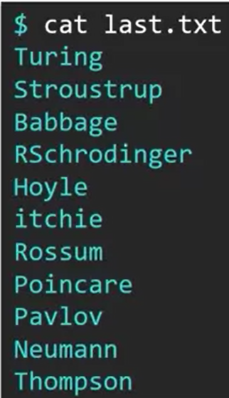 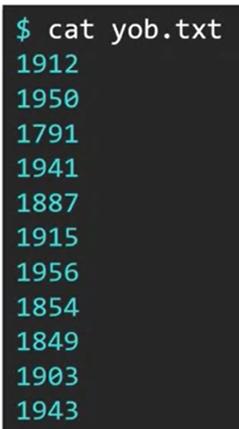

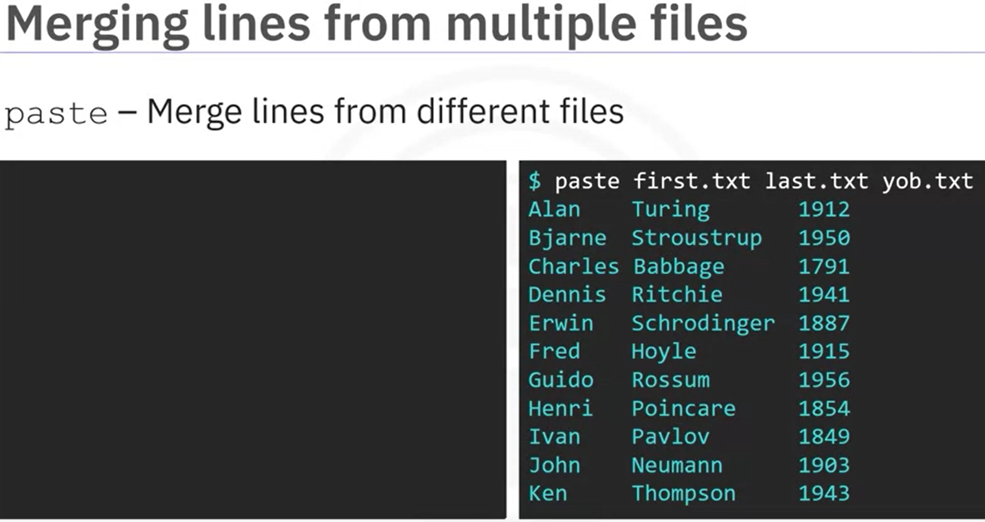

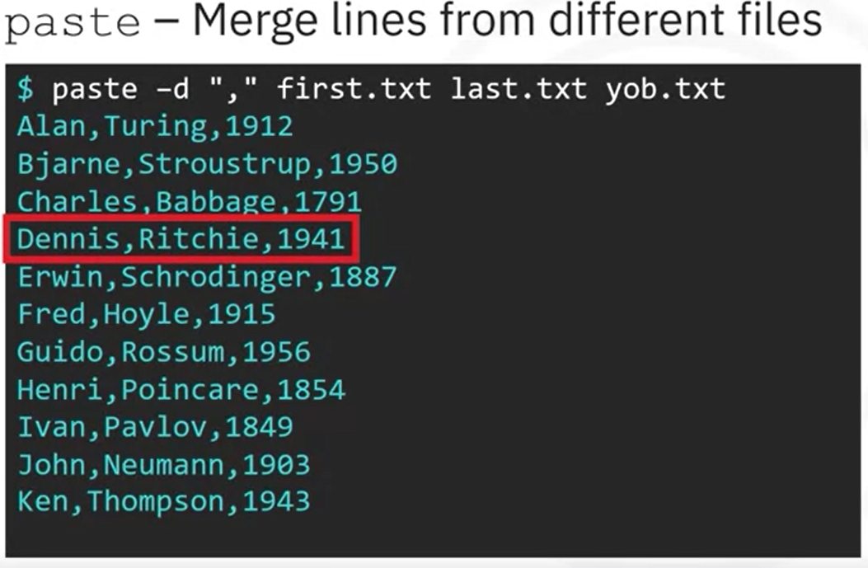

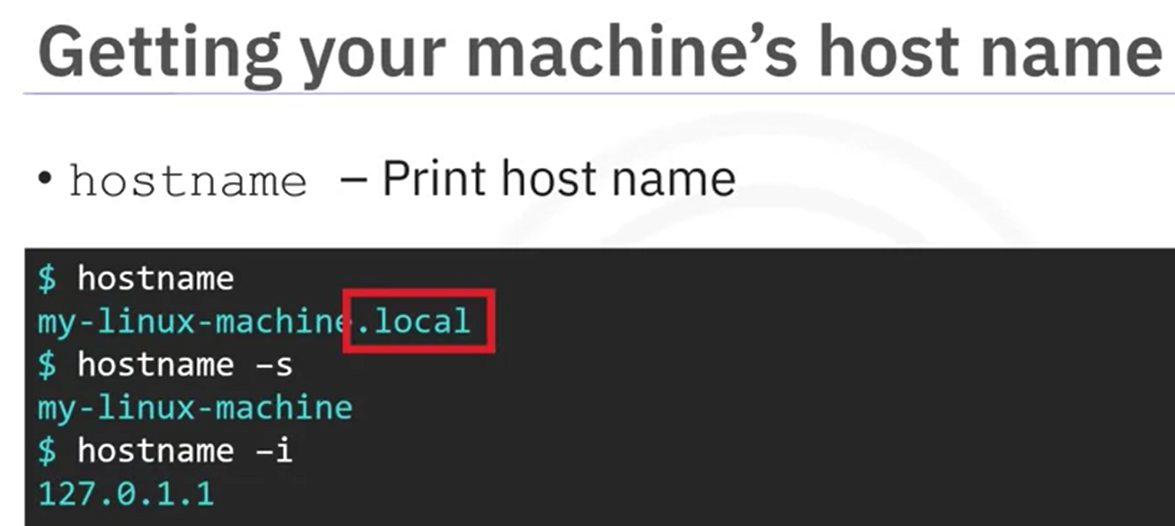

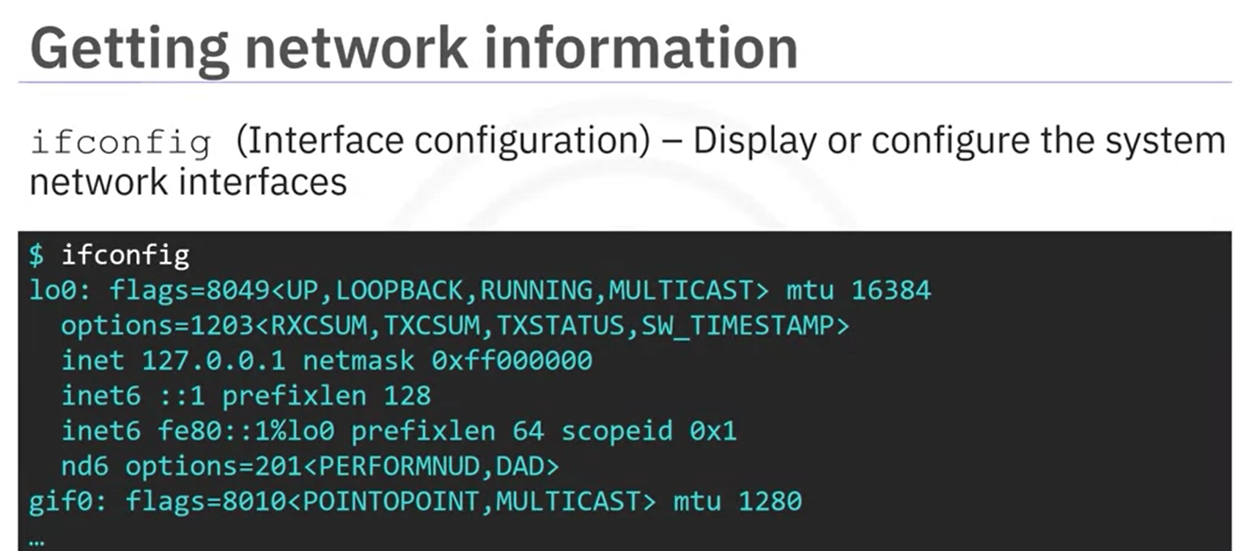

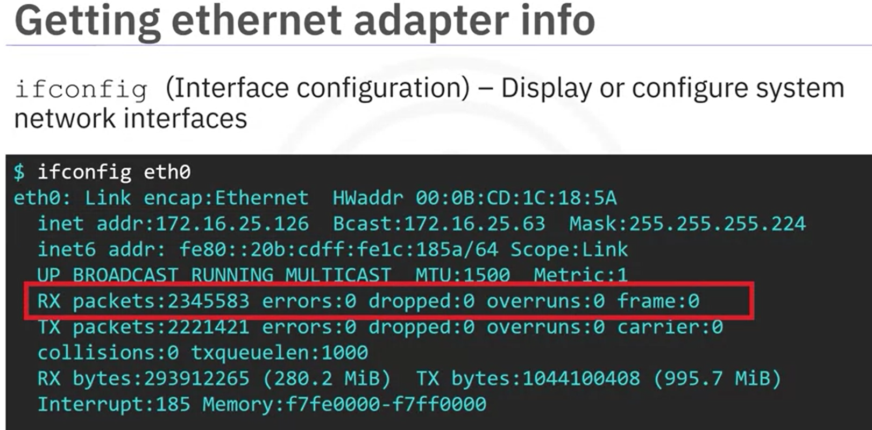

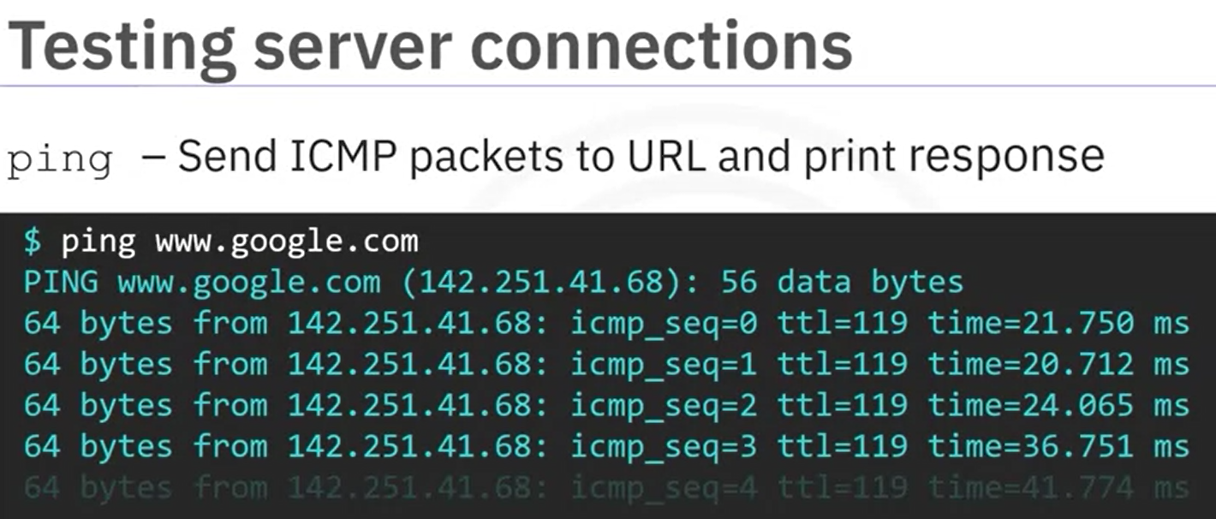

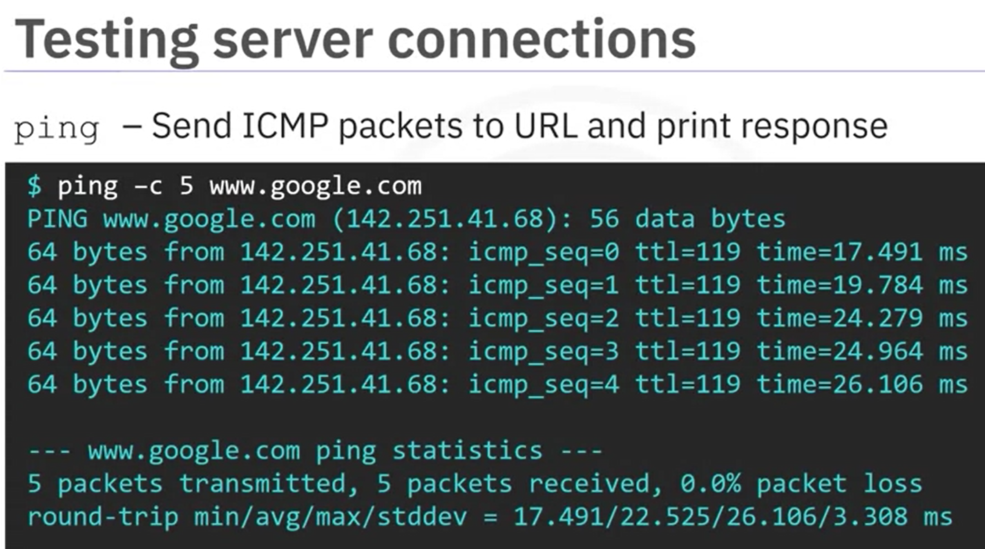

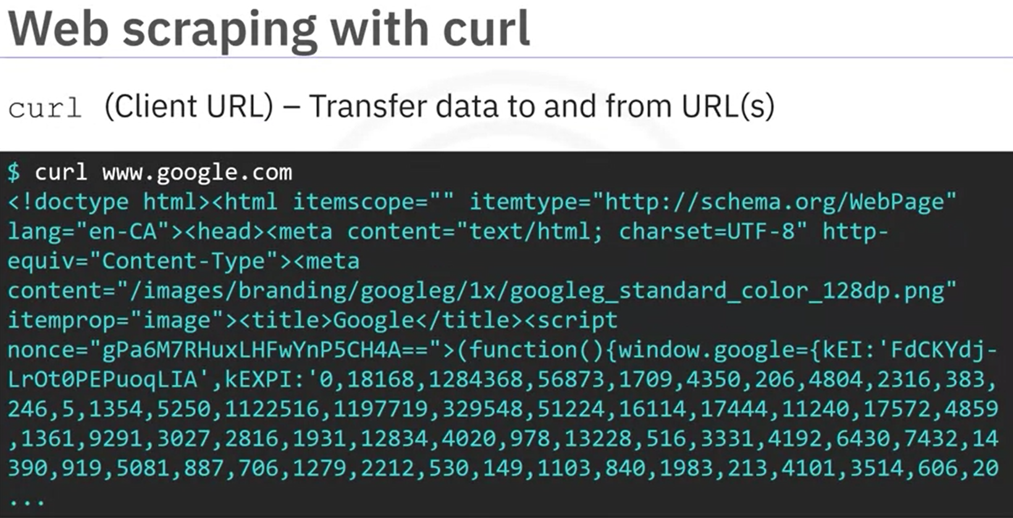

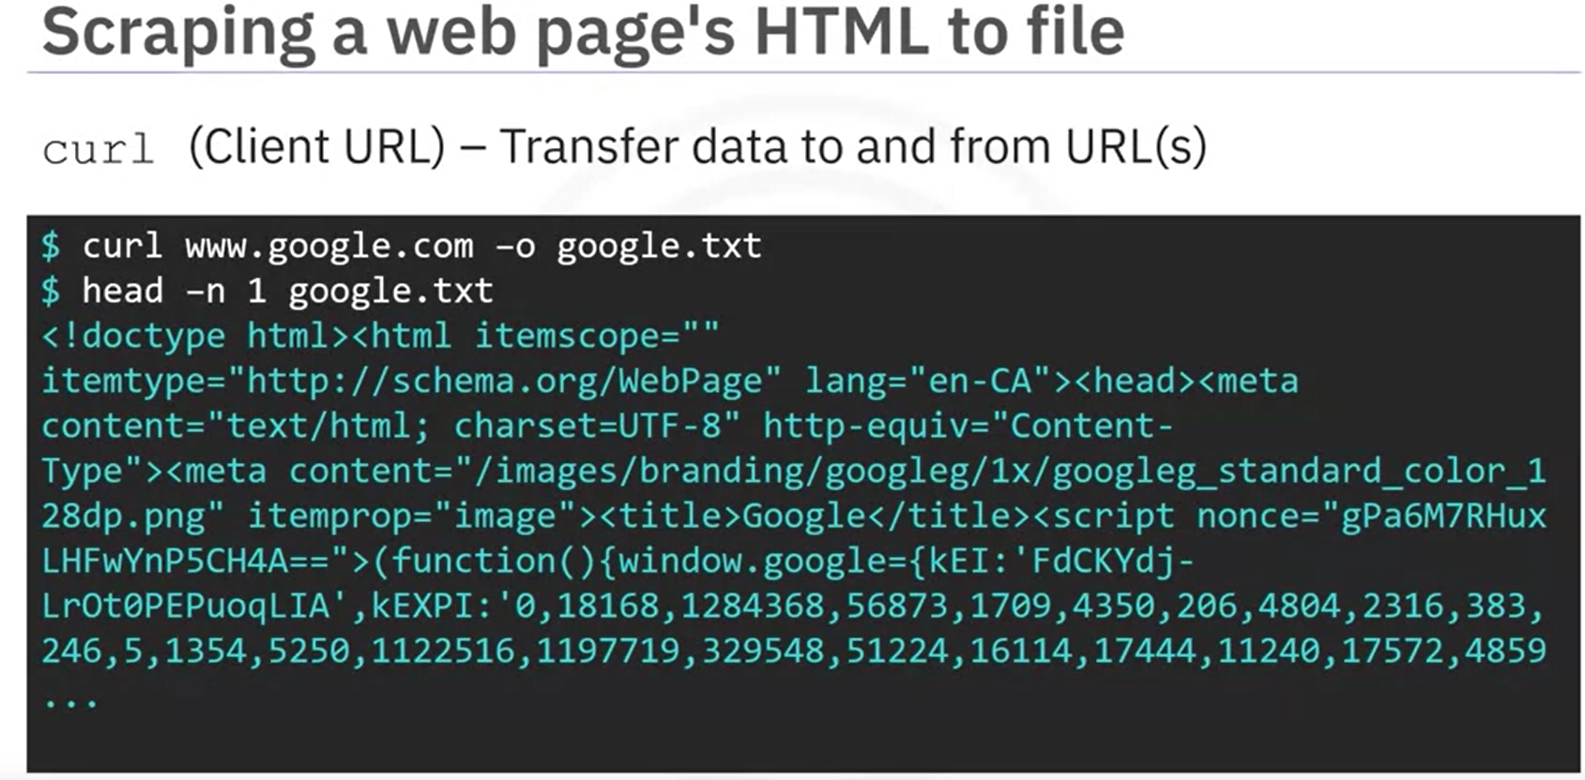

CURL COMMAND

To download a file

curl --insecure --fail --show-error --output <filename> http://<link>

To get the file on output only

curl --insecure --fail --show-error GET http://<link>

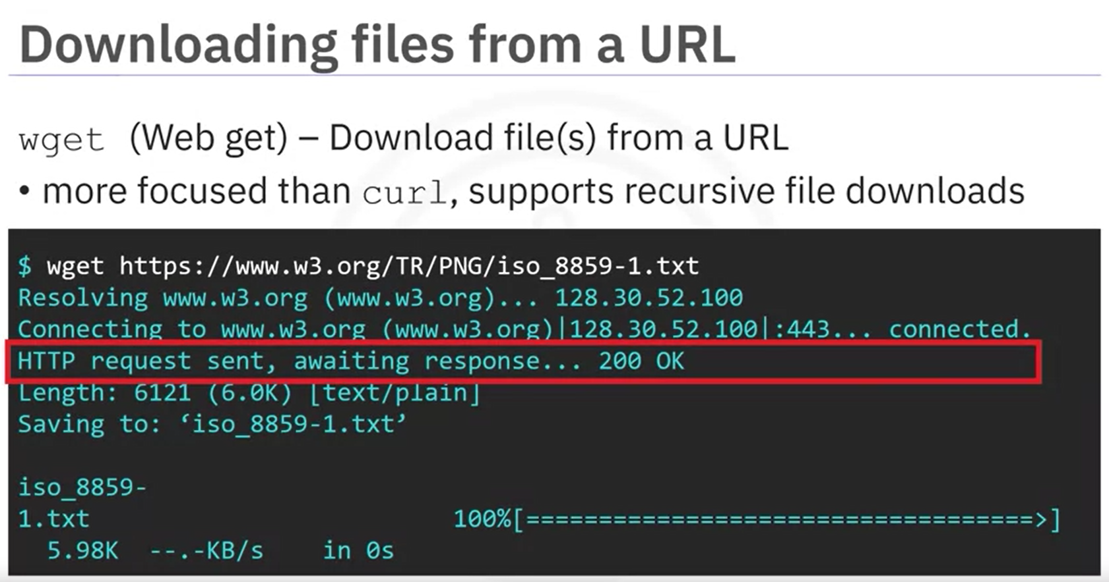

**Archiving**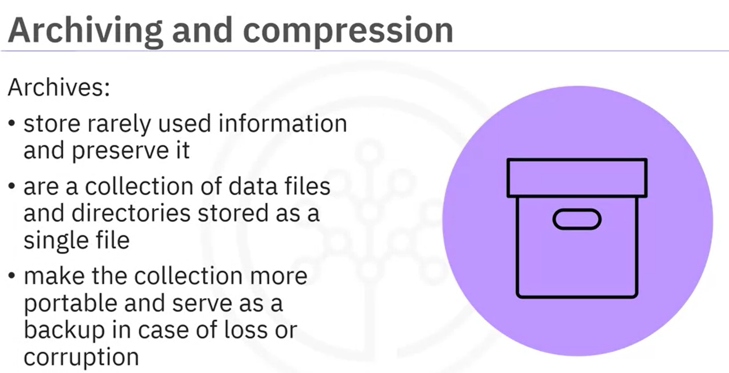

**Compression**

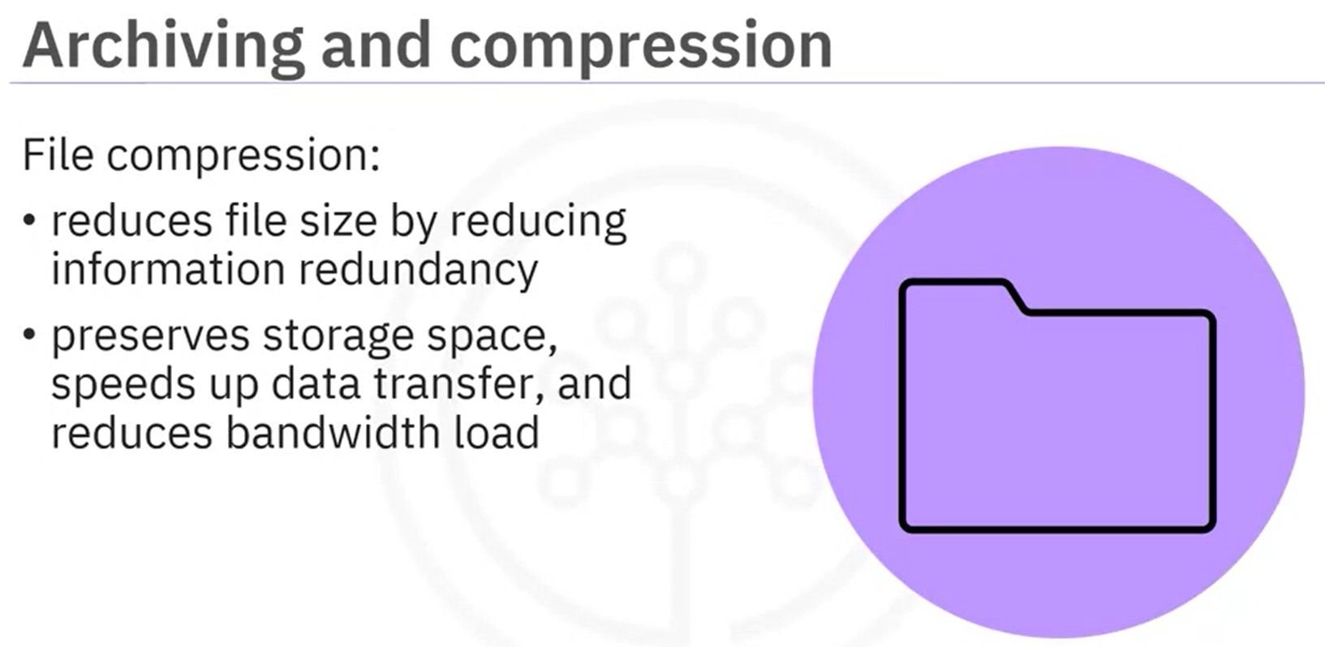

* **Archive**

A popular term for an archived tar file is a “tar ball.” To archive your entire notes directory, including its subdirectories and all files within, enter the command: “tar -cf,” a name for the archived file, such as “notes.tar,” followed by the file or directory you wish to archive, which is “notes” The ‘c’ option means “create a new archive”, and the ‘f’ flag tells tar to interpret its input from the file rather than from the default, which is standard input.

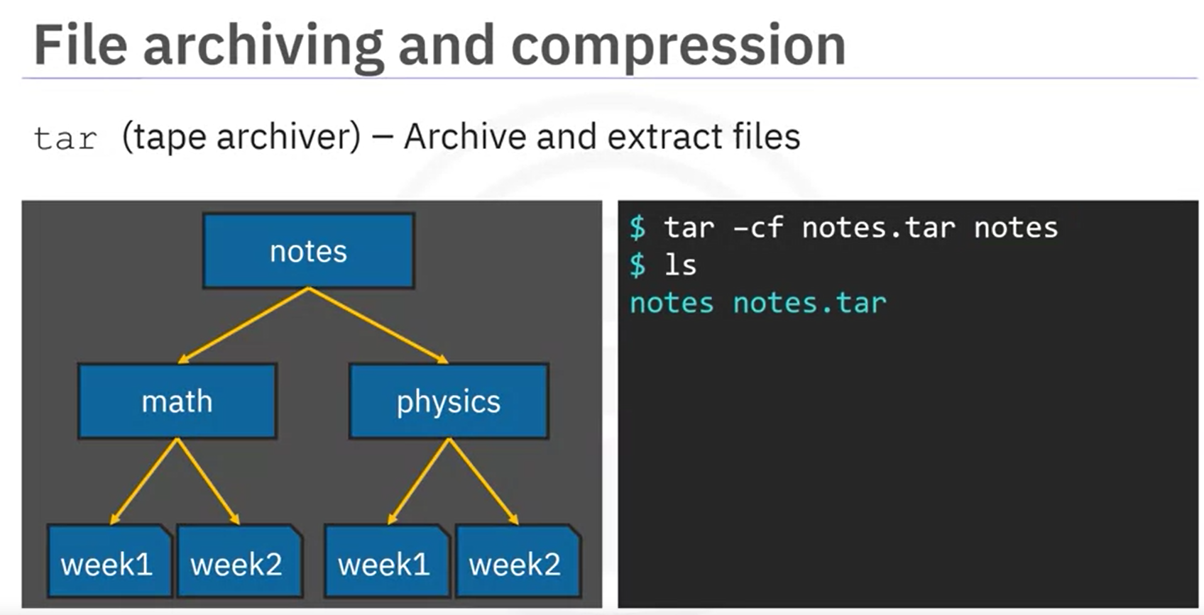

* **Archive & Compress**

If you would also like your archive to be compressed, you can enter the same command, except now you include the “-z” option, which filters the archive file through a GNU compression program called g-zip. Adding the suffix “.gz” to the output name, ensures that Windows-based programs, for example, will correctly recognize the file type.

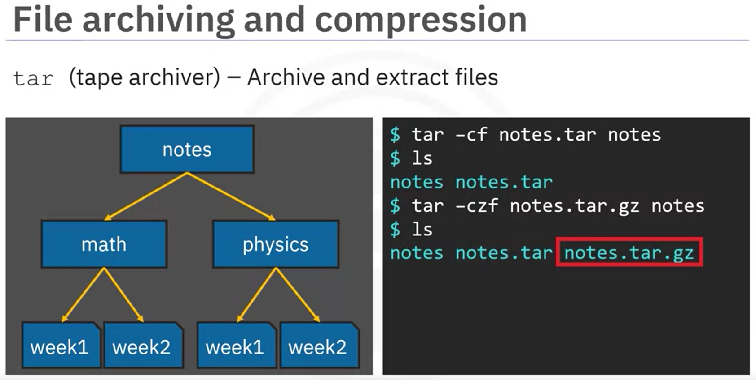

* **List the contents of a tarball**

You can check the contents of your archived notes file by calling tar on your "notes" tar ball with the “-t,” or “list” option. This lists all the files and directories in your tar ball.

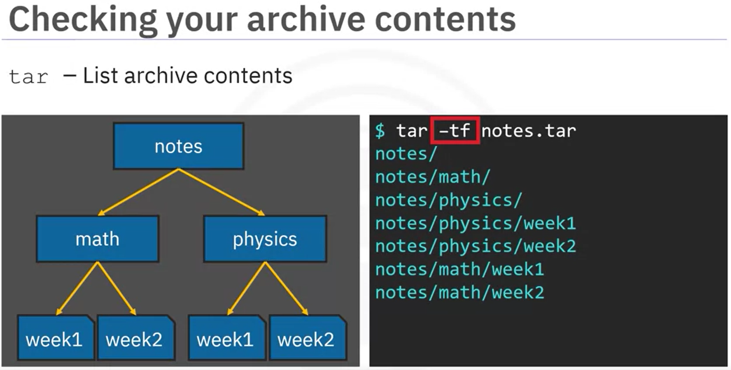

* **De-Archive**

You can also unpack, or “de-archive” your archived files using the tar command. You can enter “tar -xf” followed by the archive file name, “notes.tar”, plus an optional destination name, for example, “notes”, which happens to be the default. The “-x” option tells tar to extract file and directory objects from the archive.

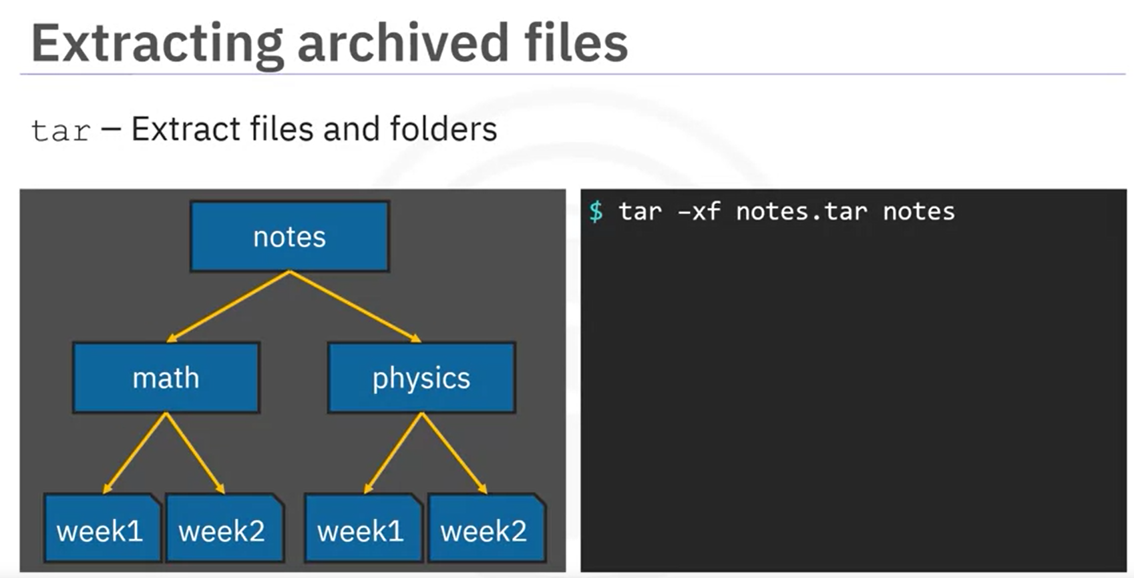

* **De-Archiving & Decompressing**

You can decompress a “tar.gz” file and extract the files from it. To unpack and decompress the notes.tar.gz file, you can enter “tar -xzf” followed by

the compressed archive file name, “notes.tar.gz” and an optional destination folder, “notes”.

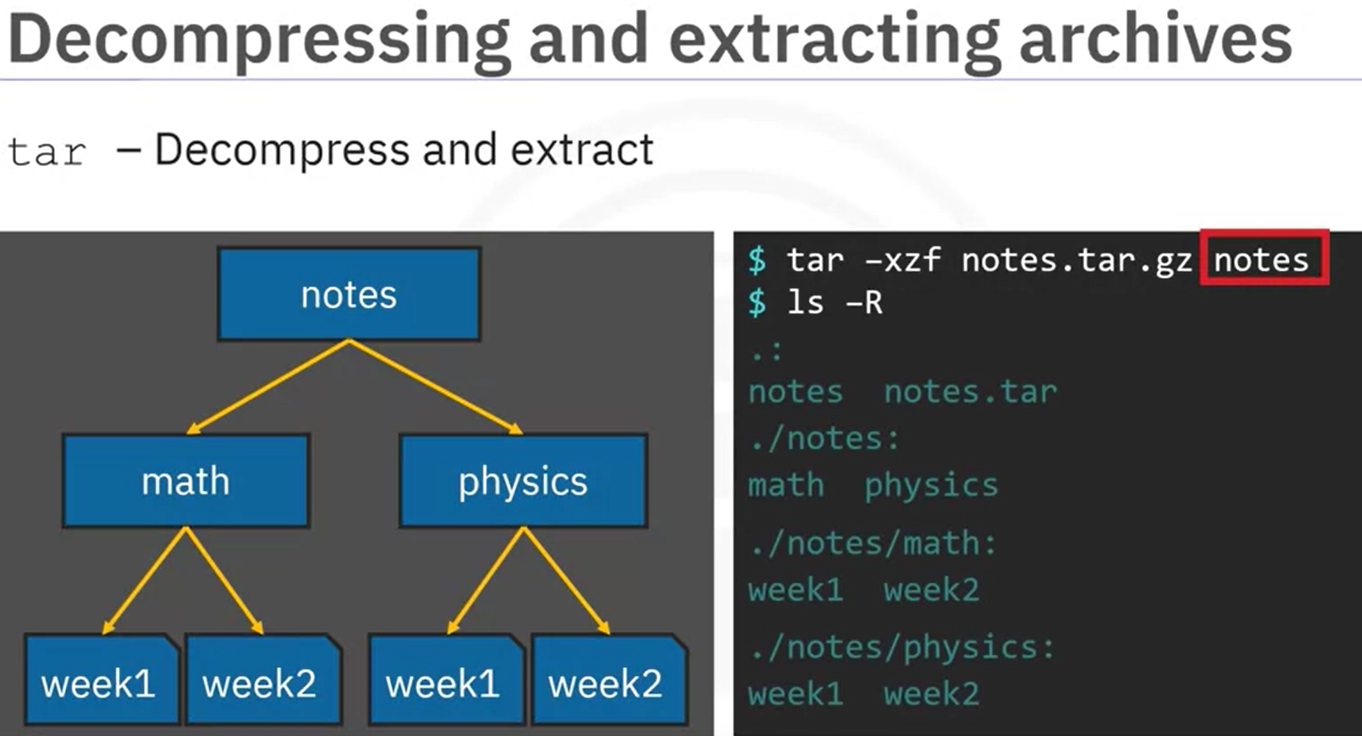

* **Zipping a file**

You can use the “zip” command to compress files and directories and package

them into a single archive. Notice the order of operations that zip implements. Zip compresses files prior to bundling them. Whereas tar, with the “-z” achieves compression by applying “g-zip” on the entire tarball, but only after bundling it. To compress your “notes” directory and package it to a “zip” file, enter “*zip -r notes.zip notes*”.

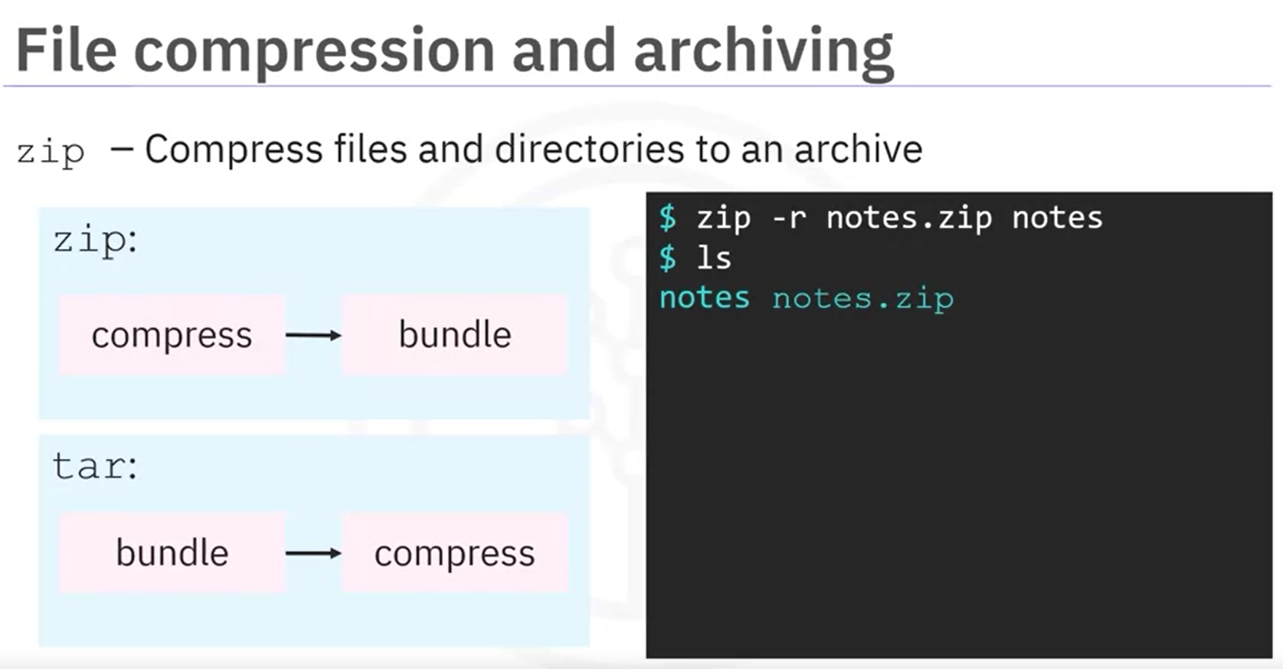

* **Unzip a file**

To unzip your notes.zip file, simply enter “*unzip notes.zip*”.

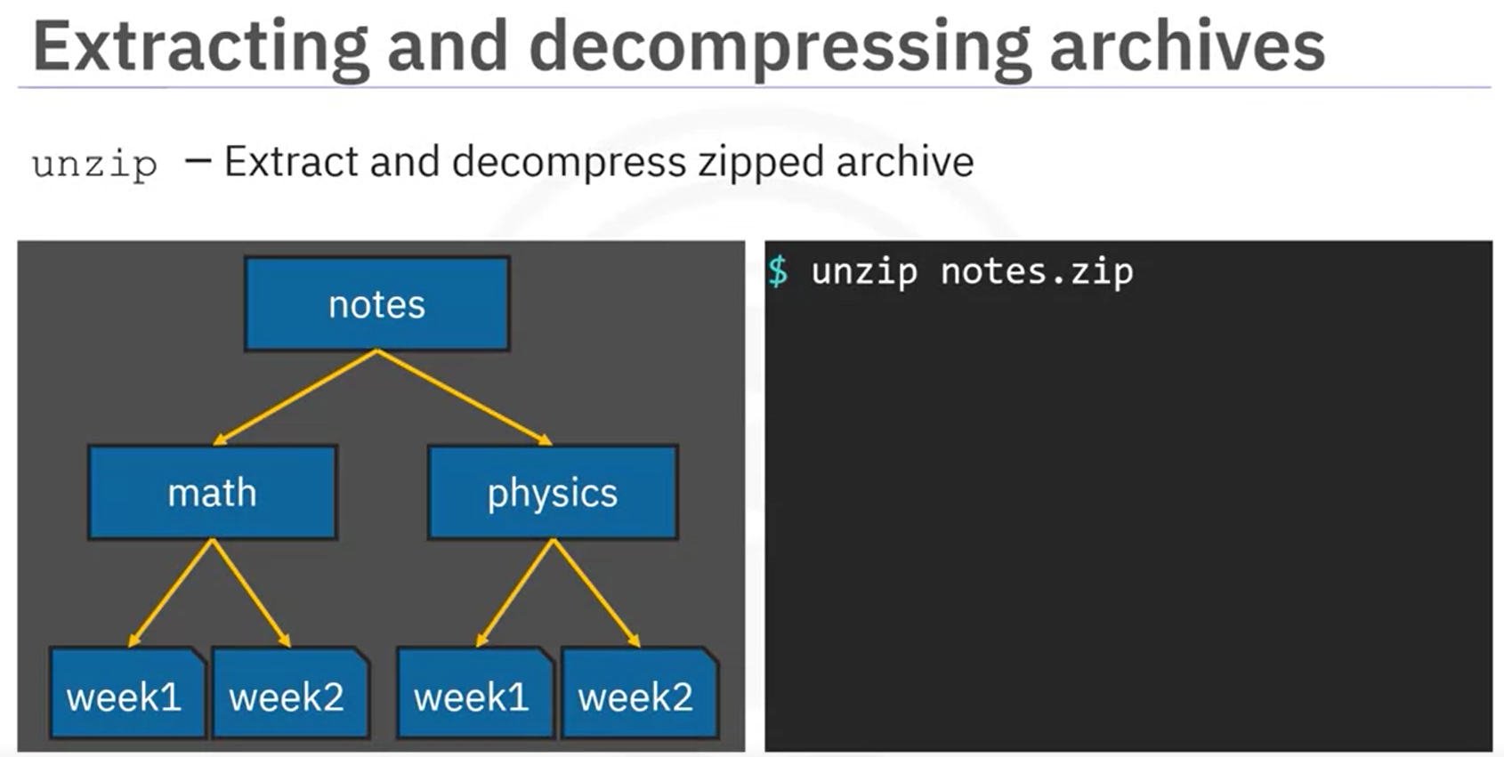

The *unzip -l <zip_file>* lets you list all the files in a zipped file. It doesn’t unzip the .zip file

In case the unzip file name is already present, and you want it unzip the file again, use *unzip -o <zip_file>*. It will force overwrite otherwise it’ll ask for permission again & again.

**Shell Scripting**

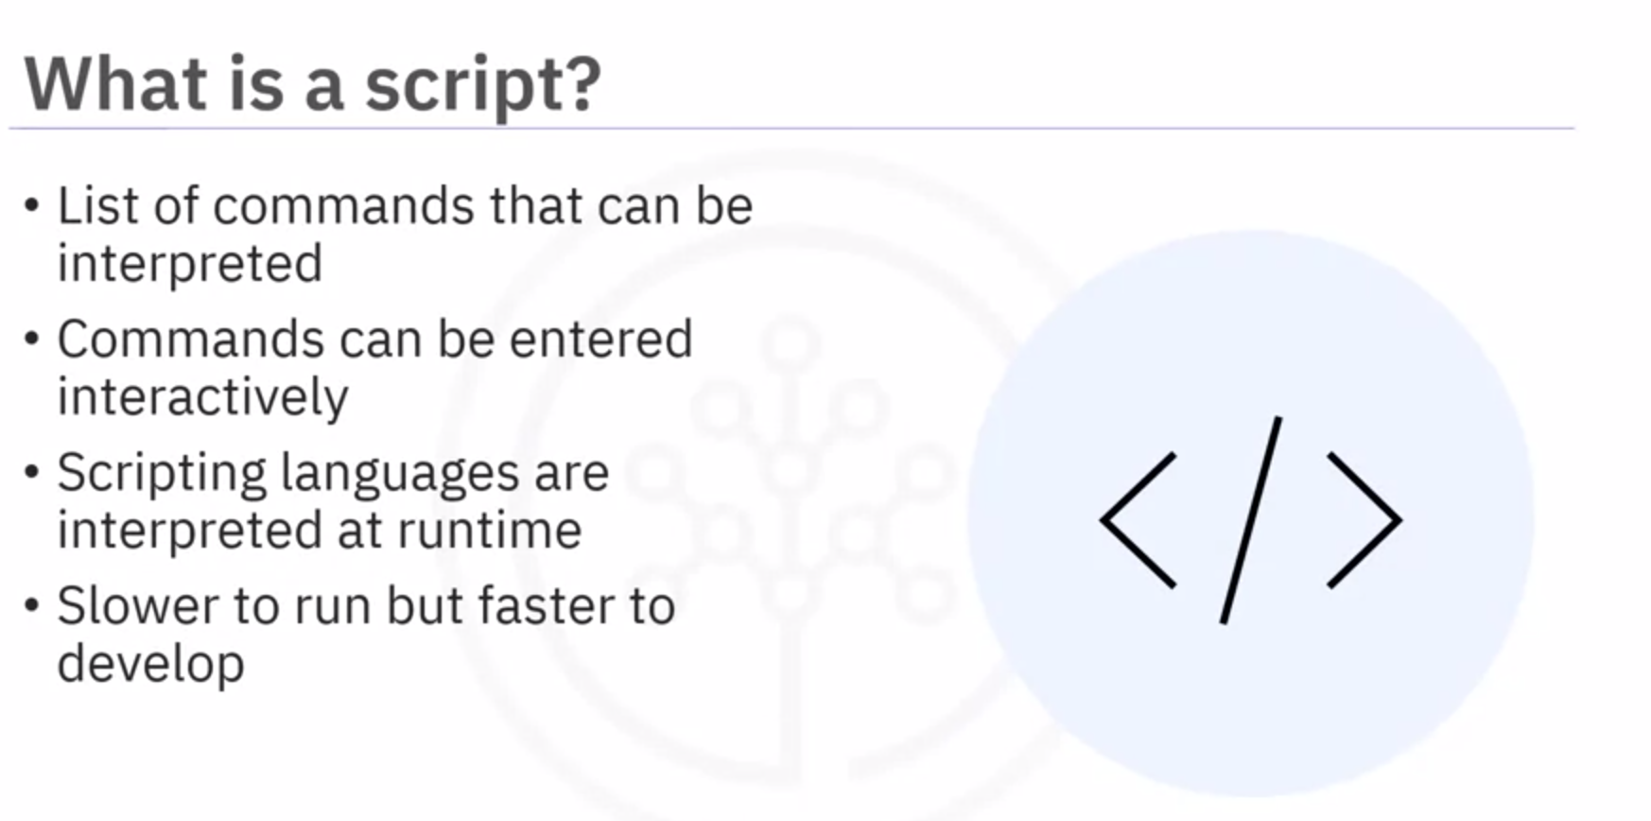

**Used of Scripting**

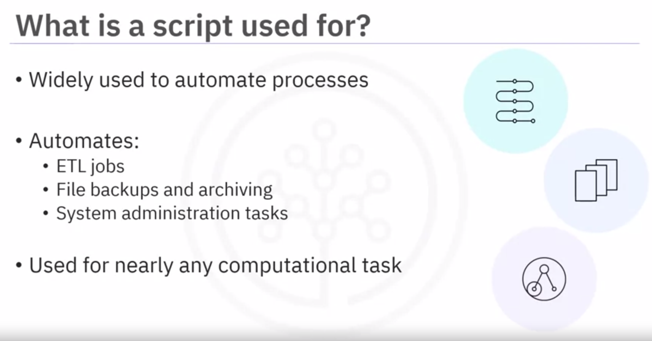

**Shell Scrip and the “shebang”**

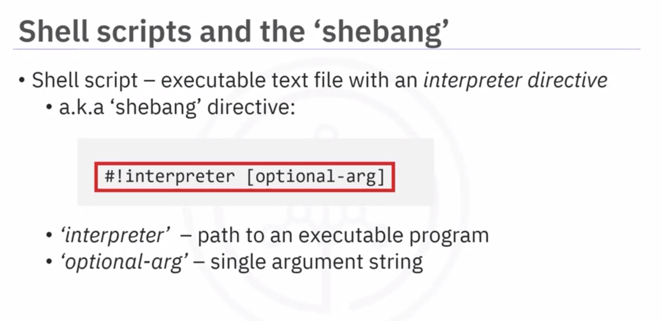

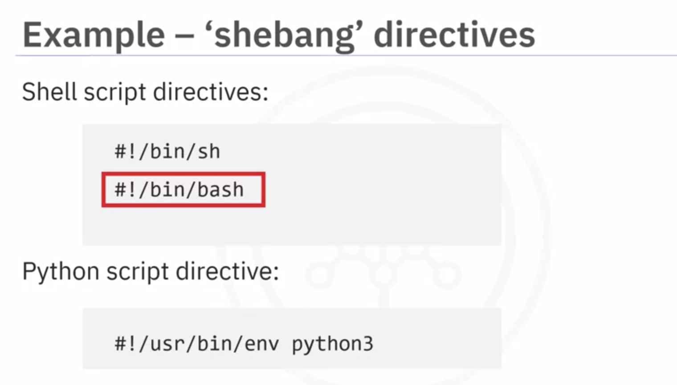

**User Input**

* To take input from the user, use the *read* command

eg: read lastname

echo $lastname

* In case you want the echo command to print on the same line, use -n flag

eg: echo -n

**Filter**

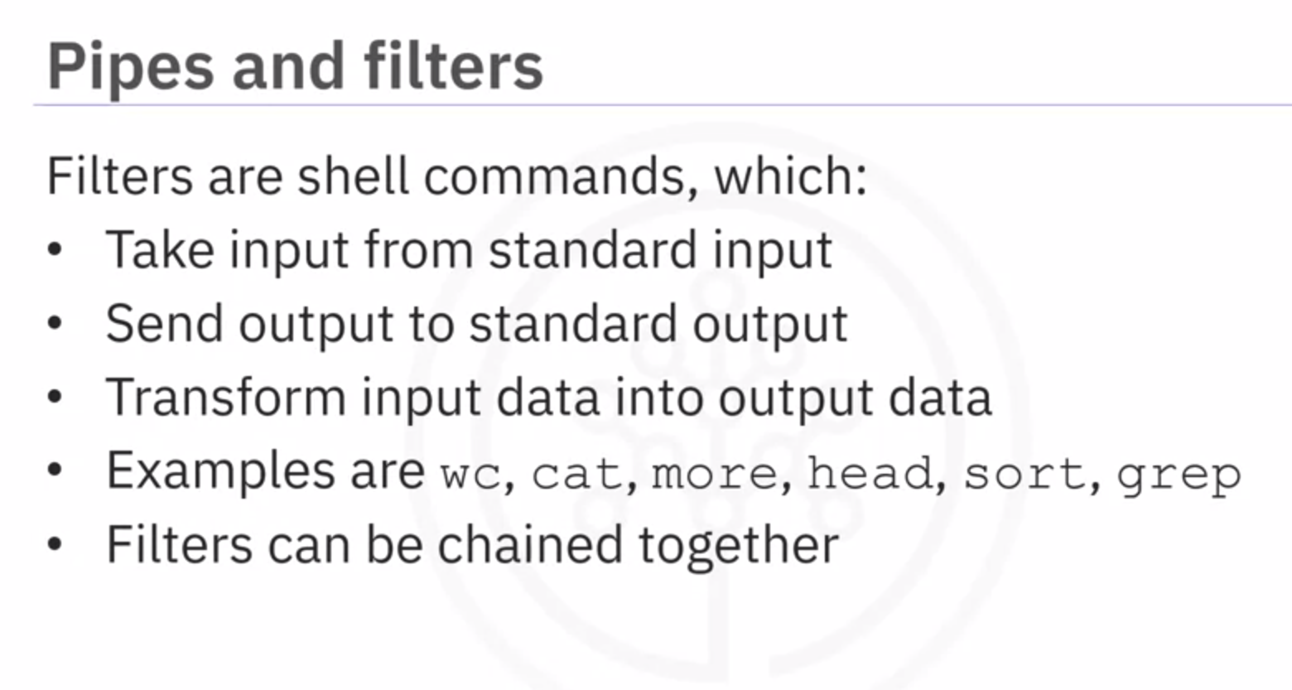

**Pipe**

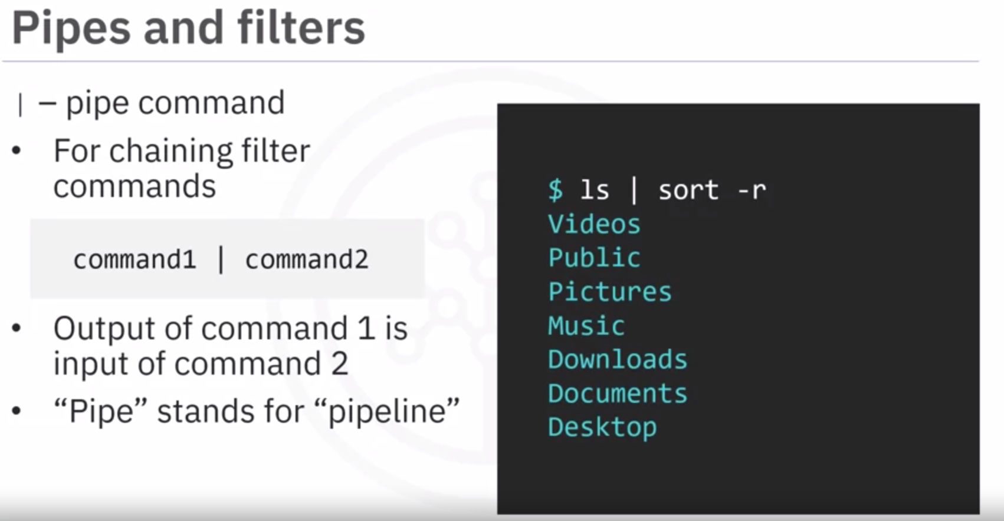

**Shell Variables**

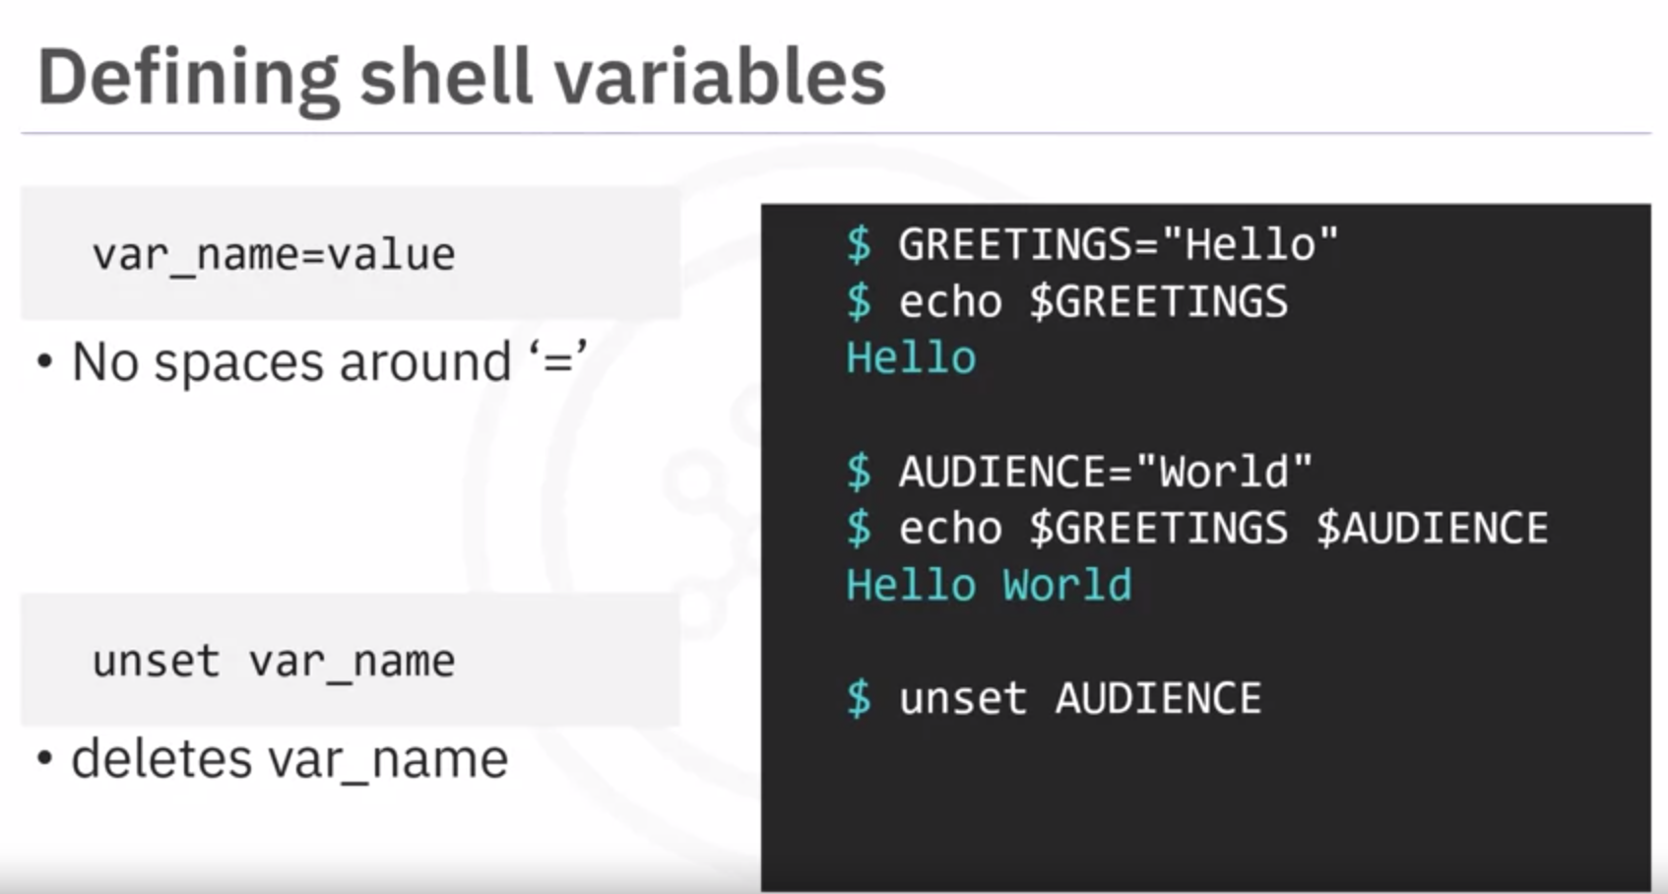

**Environment Variables**

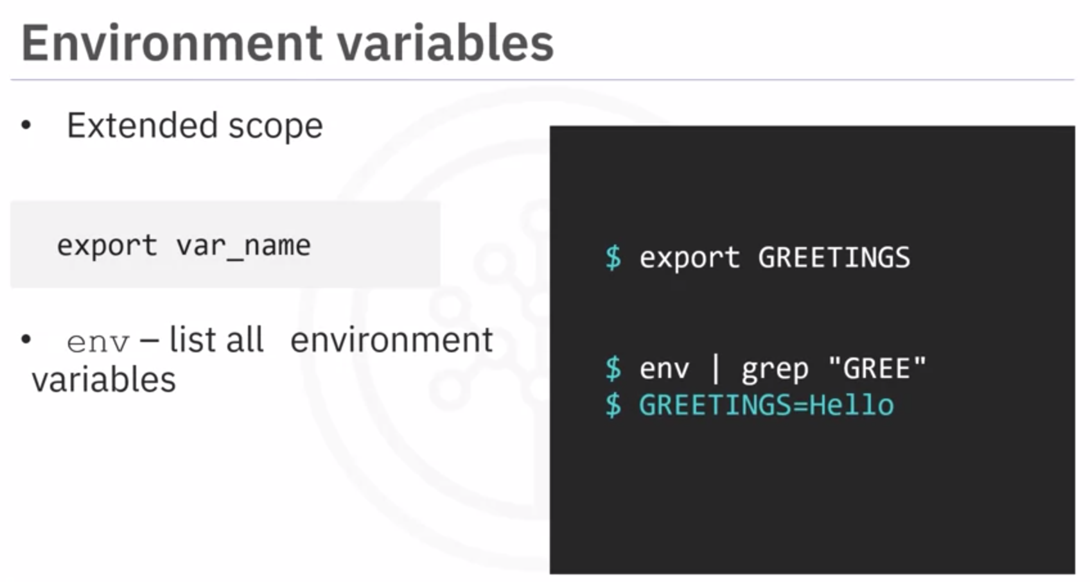

* To print environment variables, use *printenv* command

**Metacharacters**

* # character acts as a comment line. The bash shell will ignore the line starting with #.
* ; character is a command separator. We can pass 2 commands on the same line by using semi-colon as a separator
  + eg: echo “Hello”; whoami
* * acts as a wildcard. Meaning any number of characters & any character can come after this sequence
  + Eg: ls /bin/ba*
* ? acts as a wildcard for single character.
  + Eg: ls /bin/?ash

**Quoting**

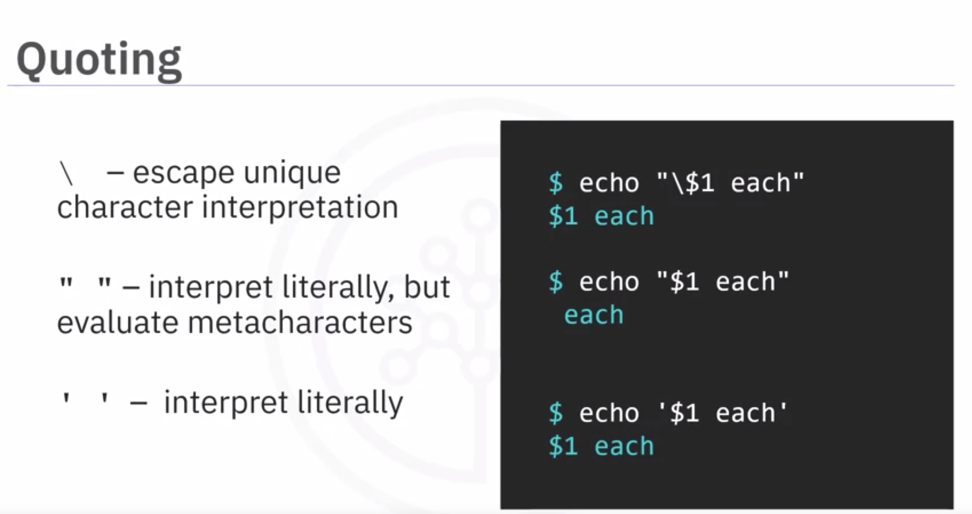

**I/O Redirection**

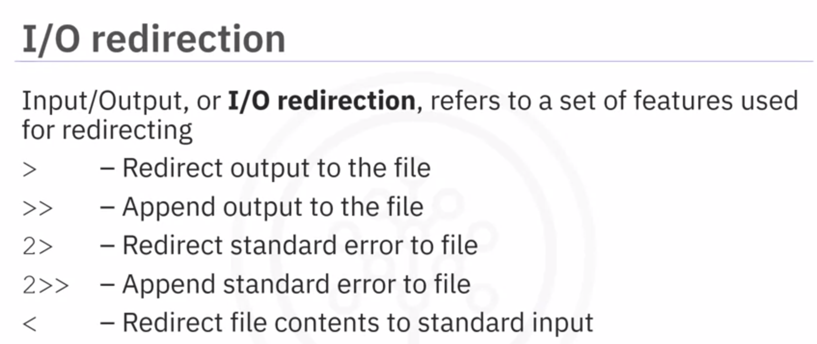

**Command Substitution**

If you want to use the output of the shell command in a shell script, then you can use command substitution.

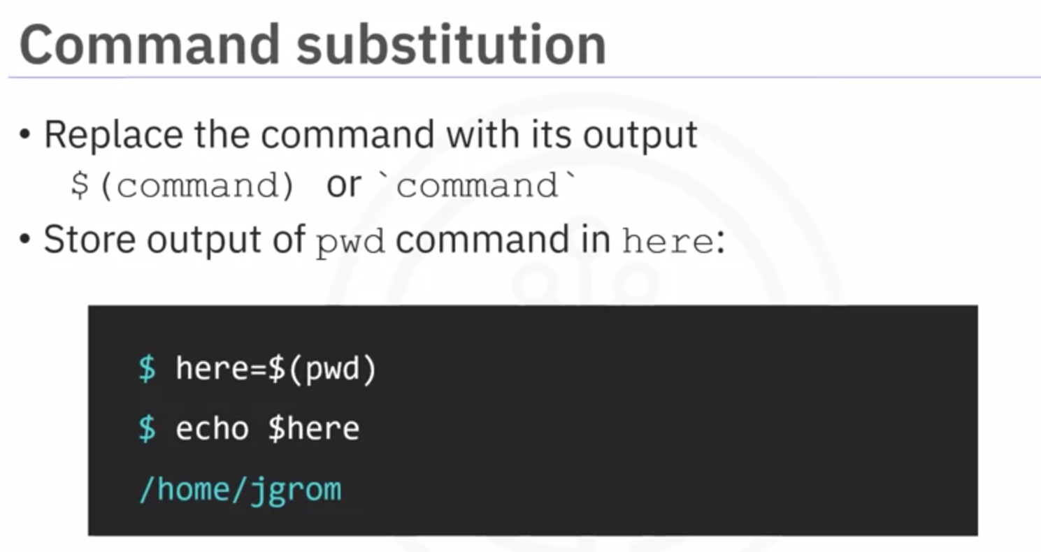

**Command Modes:**

Command line has 2 modes:

1. Batch mode - In this mode the command2 runs only after the execution of command1
2. Concurrent mode - In this the commands run in parallel and are separated by ‘&’ and the command before & runs in background while the command after & runs in the foreground.

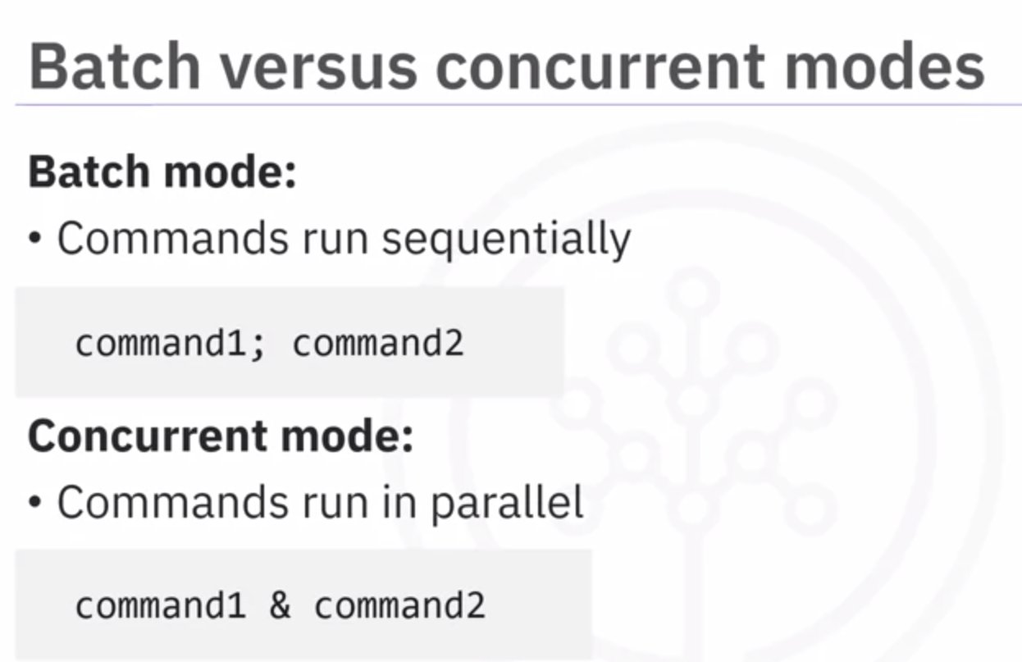

## Conditionals

**Conditionals**, or if statements, are a way of telling a script to do something only under a specific condition.

Bash script conditionals use the following if-then-else syntax:

1. if [ condition ]
2. then
3. statement_block_1
4. else
5. statement_block_2
6. fi

If the condition is true, then Bash executes the statements in statement_block_1 before exiting the conditional block of code. After exiting, it will continue to run any commands after the closing fi.

Alternatively, if the condition is false, Bash instead runs the statements in statement_block_2 under the else line, then exits the conditional block and continues to run commands after the closing fi.

***Tips:***

* *You must always put spaces around your condition within the square brackets [ ].*
* *Every if condition block must be paired with a fi to tell Bash where the condition block ends.*
* *The else block is optional but recommended. If the condition evaluates to false without an else block, then nothing happens within the if condition block. Consider options such as echoing a comment in statement_block_2 to indicate that the condition was evaluated as false.*

In the following example, the condition is checking whether the number of command-line arguments read by some Bash script, $#, is equal to 2.

1. if [[ $# == 2 ]]
2. then
3. echo "number of arguments is equal to 2"
4. else
5. echo "number of arguments is not equal to 2"
6. fi

Notice the use of the double square brackets, which is the syntax required for making integer comparisons in the condition [[ $# == 2 ]].

You can also make string comparisons. For example, assume you have a variable called string_var that has the value "Yes" assigned to it. Then the following statement evaluates to true:

1. 1
2. `[ $string_var == "True" ]`

Notice you only need single square brackets when making string comparisons.

You can also include multiple conditions to be satisfied by using the "and" operator && or the "or" operator ||. For example:

1. if [ condition1 ] && [ condition2 ]
2. then
3. echo "conditions 1 and 2 are both true"
4. else
5. echo "one or both conditions are false"
6. fi
7. if [ condition1 ] || [ condition2 ]
8. then
9. echo "conditions 1 or 2 are true"
10. else
11. echo "both conditions are false"
12. fi

## Logical operators

The following logical operators can be used to compare integers within a condition in an if condition block.

==: is equal to

If a variable a has a value of 2, the following condition evaluates to true; otherwise, it evaluates to false.

1. $a == 2

!=: is not equal to

If a variable a has a value different from 2, the following statement evaluates to true. If its value is 2, then it evaluates to false.

1. a != 2

***Tip****: The ! logical negation operator changes true to false and false to true.*

<=: is less than or equal to

If a variable a has a value of 2, then the following statement evaluates to true:

1. a <= 3

and the following statement evaluates to false:

1. a <= 1

Alternatively, you can use the equivalent notation -le in place of <=:

1. a=1
2. b=2
3. if [ $a -le $b ]
4. then
5. echo "a is less than or equal to b"
6. else
7. echo "a is not less than or equal to b"
8. fi

## Arithmetic calculations

You can perform integer addition, subtraction, multiplication, and division using the notation $(()).  
For example, the following two sets of commands both display the result of adding 3 and 2.

1. echo $((3+2))

Or

1. a=3
2. b=2
3. c=$(($a+$b))
4. echo $c

Bash natively handles integer arithmetic but does not handle floating-point arithmetic. As a result, it will always truncate the decimal portion of a calculation result.

For example:

1. echo $((3/2))

prints the truncated integer result, 1, not the floating-point number, 1.5.

The following table summarizes the basic arithmetic operators:

| **Symbol** | **Operation** |
| --- | --- |
| + | addition |
| - | subtraction |
| * | multiplication |
| / | division |

## Arrays

The **array** is a Bash built-in data structure. An array is a space-delimited list contained in parentheses. To create an array, declare its name and contents:

1. my_array=(1 2 "three" "four" 5)

This statement creates and populates the array my_array with the items in the parentheses: 1, 2, "three", "four", and 5.

You can also create an empty array by using:

1. declare -a empty_array

If you want to add items to your array after creating it, you can add to your array by appending one element at a time:

1. my_array+="six"
2. my_array+=7

This adds elements "six" and 7 to the array my_array.

By using indexing, you can access individual or multiple elements of an array:

1. # print the first item of the array:
2. echo ${my_array[0]}
3. # print the third item of the array:
4. echo ${my_array[2]}
5. # print all array elements:
6. echo ${my_array[@]}

Declare an array and load it with lines of text from a file:

my_array=($(echo $(cat column.txt)))

## for loops

You can use a construct called a for loop along with indexing to iterate over all elements of an array.

For example, the following for loops will continue to run repeatedly until every element is printed:

1. for item in ${my_array[@]}; do
2. echo $item
3. done

OR

1. for i in ${!my_array[@]}; do
2. echo ${my_array[$i]}
3. done

The for loop requires a ; do component in order to cycle through the loop. Additionally, you need to terminate the for loop block with a done statement.

Another way to implement a for loop when you know how many iterations you want is as follows. For example, the following code prints the number 0 through 6.

1. N=6
2. for (( i=0; i<=$N; i++ )) ; do
3. echo $i
4. done

You can use for loops to accomplish all sorts of things. For example, you could count the number of items in an array or sum up its elements, as the following Bash script does:

1. #!/usr/bin/env bash
2. # initialize array, count, and sum
3. my_array=(1 2 3)
4. count=0
5. sum=0
6. for i in ${!my_array[@]}; do
7. # print the ith array element
8. echo ${my_array[$i]}
9. # increment the count by one
10. count=$(($count+1))
11. # add the current value of the array to the sum
12. sum=$(($sum+${my_array[$i]}))
13. done
14. echo $count
15. echo $sum

**Cron**

* Job Scheduling

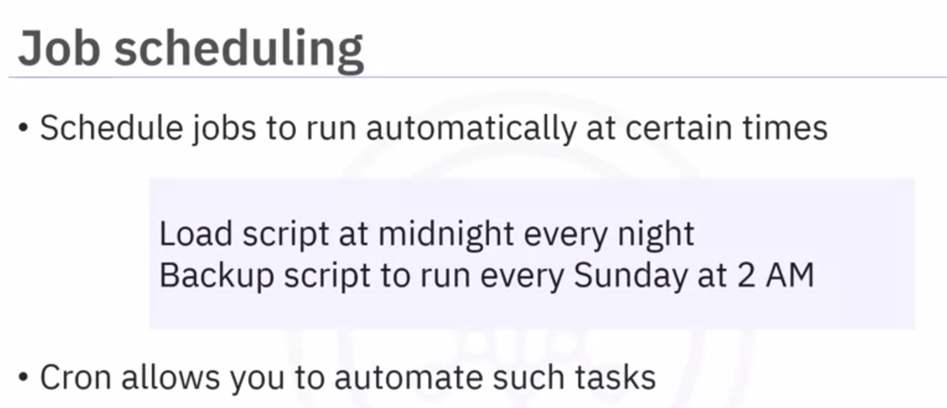

* Cron - Cron is the general name of the tool that runs scheduled jobs consisting of shell commands or shell scripts.
* Crond - Crond is the daemon or service that interprets “crontab files” every minute and submits the corresponding jobs to cron at scheduled times.
* Crontab - A crontab, short for “cron table,” is a file containing jobs and schedule data. Crontab is also a command that invokes a text editor to allow you to edit a crontab file.

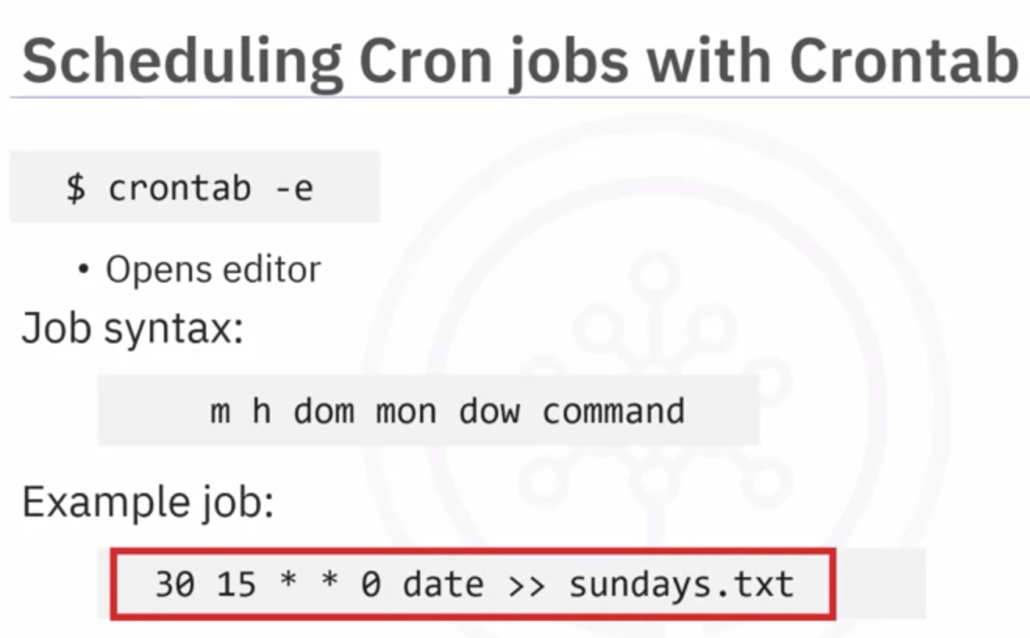

m - minute

h - hour

dom - day of the month

mon - month

dow - day of the week

